**Appendix for “Does Feedback Enhance Diversity in Selection Decisions?”**

Table of Contents

Supplemental Studies 4

Study S1 4

Study S2A 7

Study S2B 9

Study S3 12

Tables 13

Table S1. Ordinary Least Squares (OLS) Regressions Predicting Attributes of the Final Three Experts to Feature on NPR Selected in Study 1 as a Function of the Pieces of Feedback Participants Were Randomly Assigned to (1) Receive on Their Initially Selected Set of 10 Experts and (2) Whether the Effect Holds for Various Robustness Tests 13

Table S2. Ordinary Least Squares (OLS) Regressions Predicting Whether the Final Biography Selected was a Woman in Study 2 as a Function of Whether Participants Were Randomly Assigned to (1) Receive Feedback on the Fraction of Their Originally Selected Set of Biographies Who Were Women and (2) Whether the Effect Holds for Various Robustness Tests 14

Table S3. Ordinary Least Squares (OLS) Regressions Predicting Attributes of the Final Film Selected in Study 3A as a Function of the Pieces of Feedback Participants Were Randomly Assigned to Receive on Their Initially Selected Set of Seven Films 15

Table S4. Ordinary Least Squares (OLS) Regressions Predicting Whether the Final Film Included a Racial Minority Protagonist in Study 3A as a Function of Whether Participants Were Randomly Assigned to (1) Receive Feedback on the Fraction of Their Originally Selected Set of Biopics that Featured a Racial Minority and (2) Whether the Effect Holds for Various Robustness Tests 16

Table S5. Ordinary Least Squares (OLS) Regressions Predicting Attributes of the Final Film Selected in Study 3B as a Function of the Pieces of Feedback Participants Were Randomly Assigned to Receive on Their Initially Selected Set of Six Films 17

Table S6. Ordinary Least Squares (OLS) Regressions Predicting Whether the Final Film Included a Woman Protagonist in Study 3B as a Function of Whether Participants Were Randomly Assigned to (1) Receive Feedback on the Fraction of Their Originally Selected Set of Biopics that Featured a Woman and (2) Whether the Effect Holds for Various Robustness Tests 18

Table S7. Ordinary Least Squares (OLS) Regressions Predicting Features of the Final Author Selected in Study 4A as a Function of the Pieces of Feedback Participants Were Randomly Assigned to Receive on Their Initially Selected Set of Six Authors 19

Table S8. Ordinary Least Squares (OLS) Regressions Predicting Whether the Final Author Was a Racial Minority in Study 4A as a Function of Whether Participants Were Randomly Assigned to (1) Receive Feedback on the Fraction of Their Originally Selected Set of Authors Who Were Racial Minorities and (2) Whether the Effect Holds for Various Robustness Tests 20

Table S9. Ordinary Least Squares (OLS) Regressions Predicting Features of the Final Author Selected in Study 4B as a Function of the Pieces of Feedback Participants Were Randomly Assigned to Receive on Their Initially Selected Set of Six Authors 21

Table S10. Ordinary Least Squares (OLS) Regressions Predicting Whether the Final Author Was a Woman in Study 4B as a Function of Whether Participants Were Randomly Assigned to (1) Receive Feedback on the Fraction of Their Originally Selected Set of Authors Who Were Women and (2) Whether the Effect Holds for Various Robustness Tests 22

Table S11. Logistic Regressions Predicting Whether the Final Panelist Selected Was a Woman in Study 5 as a Function of Assignment to Gender Feedback and Candidate Pool Composition Conditions 23

Table S12. Comparison of the Effects of Our Descriptive Feedback Intervention in Studies 3A, 3B, 4A and 4B with the Effects of a Simulated Quota Requiring that at Least One (1) Woman be Selected (Studies 3B and 4B) or (2) Racial Minority be Selected (Studies 3A and 4A) 24

Table S13. Demonstration of Quota Rule Implementation 25

Table S14. Ordinary Least Squares (OLS) Regressions Predicting Whether the Final Selectee in Studies 3A, 3B, 4A and 4B Was a Woman (Studies 3B and 4B) or Was a Racial Minority (Studies 3A and 4A) as a Function of (1) the Proportion of Initial Selectees Who Were Women (in Studies 3B and 4B) or Racial Minorities (in Studies 3A and 4A) and (2) Assignment to Our Synthetic Quota Condition 25

Table S15. Ordinary Least Squares (OLS) Regressions Predicting Features of the Final Panelist Selected in Study S1 as a Function of the Pieces of Feedback Participants Were Randomly Assigned to Receive on Their Initially Selected Set of Six Panelists 27

Table S16. Ordinary Least Squares (OLS) Regressions Predicting Whether the Final Panelist Was a Woman in Study S1 as a Function of Whether Participants Were Randomly Assigned to (1) Receive Feedback on the Fraction of Their Originally Selected Set of Panelists Who Were Women and (2) Whether the Effect Holds for Various Robustness Tests 28

Table S17. Ordinary Least Squares (OLS) Regressions Predicting the Effect of Gender Feedback by Whether Participants Were Encouraged to Focus on Gender Diversity for Their Seventh and Final Panelist Selection in Study S2A 29

Table S18. Ordinary Least Squares (OLS) Regressions Predicting Features of the Final Panelist Selected in Study S2A as a Function of the Pieces of Feedback Participants Were Randomly Assigned to Receive on Their Initially Selected Set of Six Panelists 30

Table S19. Ordinary Least Squares (OLS) Regressions Predicting Whether the Final Panelist Was a Woman in Study S2A as a Function of Whether Participants Were Randomly Assigned to (1) Receive Feedback on the Fraction of Their Originally Selected Set of Panelists Who Were Women, (2) Whether They Were Assigned to the Diversity Encouragement Conditions, and (3) Whether the Effect Holds for Various Robustness Tests 31

Table S20. Ordinary Least Squares (OLS) Regressions Predicting Whether the Final Podcast Selected in Study S2B Featured a Woman Host as a Function of (1) Whether Participants Were Randomly Assigned to Receive Feedback on The Gender of the Host of Their Initially Selected Set of Six Podcasts and (2) Whether Participants Receive an Injunctive Norm Message Encouraging a Focus on the Gender Diversity of Podcast Hosts When Making Their Final Podcast Selection 32

Table S21. Ordinary Least Squares (OLS) Regressions Predicting Features of the Final Podcast Selected in Study S2B as a Function of the Pieces of Feedback Participants Were Randomly Assigned to Receive on Their Initially Selected Set of Six Podcasts 33

Table S22. Ordinary Least Squares (OLS) Regressions Predicting Whether the Final Panelist Was a Woman in Study S2B as a Function of Whether Participants Were Randomly Assigned to (1) Receive Feedback on the Fraction of Their Originally Selected Set of Podcasts Who Included a Woman Host, (2) Whether They Were Assigned to the Diversity Encouragement Conditions, and (3) Whether the Effect Holds for Various Robustness Tests 34

Figures 35

Figure S1. Pictures of Study 2’s (A) On-campus Recruitment Display and (B) Final On-campus Display of Selected Books. 35

Figure S2. The Effect of Random Assignment to Receive Different Pieces of Descriptive Feedback about Prior Film Selections on Which Film is Subsequently Added to the Set Featured in a Facebook Advertisement in Study 3A (Panel A) and Study 3B (Panel B) 36

Figure S3. Study 4. The Effect of Random Assignment to Receive Different Pieces of Descriptive Feedback about Prior Author Selections on Which Author is Subsequently Added to the Library Reading List in Study 4A (Panel A) and Study 4B (Panel B) 38

Figure S4. Study S1. The Effect of Random Assignment to Receive Descriptive Feedback on Different Attributes of the Six People Initially Selected for a Panel on Who is Subsequently Chosen As the Final Panelist. 40

Figure S5. Study S2A. The Effect of Random Assignment to Receive Descriptive Feedback on a Set of 6 Original Business Panel Selections on Which Business Panelist is Subsequently Chosen to be Featured as the 7th Panelist, among Participants both Encouraged to Focus on Diversity and Not Encouraged to Focus on Diversity. 41

Figure S6. Study S2B. The Effect of Random Assignment to Receive Descriptive Feedback on a Set of 6 Original Podcast Selections on Which Podcast is Subsequently Chosen to be Featured as the 7th Podcast, among Participants Encouraged to Focus on Diversity and not Encouraged to Focus on Diversity 42

Materials 43

Study 1 43

Study 2 47

Study 3A 52

Study 3B 56

Study 4A 60

Study 4B 65

Study 5 71

Study S1 78

Study S2A 81

Study S2B 85

# 

# Supplemental Studies

## Study S1

Study S1 was a conceptual replication of Study 1A and Study 1B in a new decision context. In Study S1, we examined how describing the gender distribution of panelists in a participant’s selected panel shaped future panel selections (Hypothesis 1) and whether this effect was larger than providing descriptive feedback about whether the panelists included CEOs, Founders, or Technologists (Hypothesis 3).

**Methods**

**Participants.** We recruited 1,000 participants through Amazon’s MTurk, as pre-registered (<https://aspredicted.org/PBR_WZL>), and paid them $0.75 (50.9% men, 47.9% women; Mage=41.25; 77.1% White, 7.9% Black, 7.1% Hispanic, 7.6% Asian, 0.3%).

**Procedure.** Participants were asked to imagine they were planning a major international business conference and had been tasked with selecting a panel of business leaders to provide insights on the global business landscape during the event. We presented a list of 25 real business leaders in randomized order to each participant. We included each leader’s name (e.g., Jeff Bezos, Mary Barra), title (e.g., Founder, CEO), and company affiliation (e.g., Amazon, General Motors). Five of the business leaders in the set of 25 were women, meaning that women were underrepresented (and yet, were roughly two-and-half times as well represented in our list as they were among Fortune 500 CEOs at the time of this study; [Fortune, 2022)](https://www.zotero.org/google-docs/?X2Vcxj) . Participants were instructed to select six leaders for their panel. After creating their six-person panel, they were presented with summary statistics describing the composition of their selections.

Participants were then randomly assigned to one of two conditions: (1) the *no* *gender feedback* condition, or (2) the *gender feedback* condition. In the *no gender feedback* condition, participants were randomly assigned to see either two or three of the following pieces of descriptive feedback about the panelists they had selected: (1) % from the tech industry, (2) % who were CEOs, and/or (3) % who founded companies. In the *gender feedback* condition, participants always received descriptive feedback about the percentage of panelists they had selected who were women, as well as two additional pieces of descriptive feedback randomly drawn from the list of feedback attributes above. After receiving this descriptive feedback, participants were asked to add a seventh panelist to their original selections from the choices remaining in the list of 25 business leaders. Finally, participants reported their demographics.

**Results**  
 Participants in all conditions first selected six panelists. Of these initial selections, 19.8% were women panelists (20.5% in the no gender feedback condition and 19.1% in the gender feedback condition, *t*(998) = 1.13, *p* = .258, 95% CI = [-0.011, 0.040]). Following our pre-registration, we ran an ordinary least squares regression (OLS) with robust standard errors to predict whether participants selected a woman as the seventh panelist. Our primary predictor was an indicator for assignment to the gender feedback condition. As shown in Figure S3 and Table S10, Model 1, participants were significantly more likely to choose a woman as their seventh panelist in the gender feedback condition (51.6% chose a woman panelist) than in the no gender feedback condition (27.75% chose a woman panelist; *B* = 0.224, 95% CI = [0.165, 0.283], *t*(998) = 7.46, *p* < .001). These results were robust to controlling for participant age, race, and gender, and analyzing our data with logistic regression (see Appendix Table S10, Models 3-4).

We also examined the effect of random assignment to receive feedback about the percent of initially selected panelists who were: (1) CEOs, (2) technologists, and (3) founders on the likelihood of selecting a panelist with the corresponding feature as the seventh panelist using OLS regressions (see Figure S3 as well as Table S9, Models 2-4). We see that feedback on these attributes has primarily null effects on subsequent decisions.

To formally test whether offering feedback about the percentage of initially selected panelists who were women had a larger effect on the subsequent selection of women panelists than offering feedback about other panelist attributes had on the subsequent selection of panelists with those attributes, we constructed three systems of simultaneous equations (Zellner 1962). For each system, we included a pair of equations: one modeling the effect of gender feedback and one modeling the effect of feedback on another panelist attribute (i.e., % were CEOs, % were technologists, or % were founders, see Table S9, Models 5-8). We then used Wald tests to formally compare the effects estimated in the paired equations. Three paired Wald tests confirmed that the effect of assignment to the gender feedback condition on the likelihood of selecting a 7th panelist who was a woman was larger than the effects of assignment to receive descriptive feedback about the % of initial panelists selected who were (1) CEOs (*F*(1, 1992) = 76.78, *p* < .001), (2) technologists (*F*(1, 1992) = 70.59, *p* < .001), or (3) founders (*F*(1, 1992) = 27.32, *p* < .001) on subsequent selections of a 7th and final panelist who was, respectively, a (1) CEO, (2) technologist, or (3) founder.

**Study S1 Discussion**

We found that providing descriptive feedback about the proportion of women panelists in a participant’s past selectees significantly increased the likelihood that participants selected a woman in the future (Hypothesis 1). On the other hand, descriptive feedback about other relevant attributions of past selectees that were not expected to trigger impression management concerns (e.g., feedback about the number of CEOs or Technologists) had a significantly smaller impact on selection decisions (Hypothesis 3)—this type of descriptive feedback, in fact, had no effect whatsoever. This finding supports our theory that descriptive feedback that does not raise concerns about the violation of injunctive norms will not motivate behavior change to the same degree as descriptive feedback that triggers impression management concerns.

## Study S2A

In Study S2A, in addition to randomly assigning some participants to receive different types of descriptive feedback about their initial candidate selections, we simultaneously randomly assigned some to receive explicit injunctive norm messaging conveying that gender diverse selectees are valued. This allowed us to benchmark the effectiveness of our descriptive feedback intervention.

**Methods**

**Participants**. We recruited 1,000 participants through Amazon’s MTurk, as pre-registered (<https://aspredicted.org/JS2_W6N>), and paid them $0.75 (47.2% men, 51.5% women; Mage=40.36; 74.1% White, 11.2% Black, 5.7% Hispanic, 8.5% Asian).

**Procedure.** The stimuli for Study S2A were identical to Study S1 (participants selected a set of six panelists to participate in a high-profile, international business conference). We used the same gender feedback manipulation as Study S1 but also varied whether participants received injunctive norm messaging or not. This resulted in a 2 (*gender feedback vs. no gender feedback*) X 2 (*injunctive norm messaging vs. no injunctive norm messaging*) design. Participants in the *injunctive norm messaging* condition saw an additional statement when receiving feedback on their first six panelist selections: “The organization planning this event cares deeply about presenting a diversity of speakers in terms of [their experience in CEO roles, their experience as company founders, their background in the technology industry] and their gender.” The terms “CEO,” “founder,” or “technologist” were only included whenever the corresponding feedback was randomly selected to be shown. In the *no injunctive norm messaging* conditions, the previous statement was omitted (thus making the procedure exactly identical to Study S1). After receiving injunctive norm messaging and/or feedback, participants were asked to select a seventh and final panelist.

**Results**

Participants in all conditions first selected six panelists. Of these initial selections, 19.8% were women panelists. There was no significant difference based on assignment to the gender feedback condition (*p* = .343) or injunctive norm condition (*p* = .904). Following our pre-registration, we ran an OLS regression with robust standard errors to predict whether the seventh and final panelist selected was a woman. Our primary predictors were indicators for assignment to the gender feedback condition and the injunctive norm messaging condition, and their interaction. As shown in Table S11, Model 1, we replicated our main effect: participants were significantly more likely to choose a woman panelist as their seventh and final panelist in the gender feedback condition (47.60% chose a woman) than in the no gender feedback condition (28.13% chose a woman; *B* = 0.193, 95% CI = [0.109, 0.277], *t*(996) = 4.50, *p* < .001). Participants were not significantly more likely to choose a woman panelist when assigned to the injunctive norm messaging condition (40.88% chose a woman) compared to the no injunctive norm messaging condition (38.31% chose a woman; *B* = 0.030, 95% CI = [-0.052, 0.112], *t*(996) = 0.72, *p* = .471). Furthermore, the interaction between gender feedback and injunctive norm messaging was not significant (*B* = -0.005, 95% CI = [-0.125, 0.115], *t*(996) = -0.07, *p* = .941), indicating that the effect of gender feedback did not differ based on whether participants received the injunctive norm message. Robustness checks are presented in Table S13. Comparisons of gender feedback effects to other feedback types (among those not receiving the injunctive norm message) are shown in Table S12 and Figure S4A; results mirror Study S1.

## Study S2B

In Study S2B, we replicate and extend the findings from Study S2A but under an incentivized decision context and with a different set of stimuli.

**Methods**

**Participants**. We recruited 1,000 participants on Amazon’s MTurk, as pre-registered ([https://osf.io/jz6sq](https://osf.io/jz6sq?view_only=215eb0a6d5744c4e94aca7483eaff6d6)), and paid them $0.75 (46.3% men, 52.8% women; Mage=43.77; 79.2% White, 8.4% Black, 4.6% Hispanic, 7.5% Asian).

**Procedure.** Our procedure here was very similar to the procedure used in Study 1. However, instead of selecting films for inclusion in a real Facebook marketing campaign, participants selected which podcasts to feature in a campaign to draw more listeners to podcasts. Participants were provided with a grid of 25 podcasts that were candidates for inclusion. Each podcast’s description included its show art overlaid with the host’s photograph, the name of the podcast’s host, a short description of the host’s profession (e.g., Actor), the year when the podcast launched, and the number of episodes of the podcast that had been created to date.

Participants were asked to select six podcasts for inclusion in the Facebook campaign. After making their selections, participants were randomly assigned to one of four conditions in a 2 (*gender feedback vs. no gender feedback*) X 2 (*injunctive norm messaging vs. no injunctive norm messaging*) design. In the *no gender feedback* condition, we presented three pieces of descriptive feedback to participants (in random order) that summarized the percentage of podcasts they had selected that: (1) were over 3 hours long, on average, (2) had been launched over three years ago, and (3) boasted over 300 episodes. In the *gender feedback* condition, participants always received feedback about the percentage of podcasts they had selected that featured a woman host, alongside two randomly drawn pieces of feedback from the list above.

Participants in the *injunctive norm messaging* condition saw an additional statement when receiving descriptive feedback about their first six podcast selections. This statement read as follows: “We care deeply about presenting podcasts that are diverse in terms of [how many episodes of the show already exist, their average episode length, how long they’ve been running] and the gender of their hosts.” The statements in the brackets pertaining to specific podcast features were only included when the feedback about the corresponding attribute was randomly selected to be provided. In the *no injunctive norm messaging* conditions, the injunctive norms statement was not provided. After receiving injunctive norm messaging and/or descriptive feedback about their initial six podcast selections, participants nominated a seventh and final podcast for inclusion in our Facebook campaign.

**Results and Discussion**

Participants in all conditions first selected six podcasts. Of these initial selections, 28.1% featured women hosts. There was no significant difference based on assignment to the gender feedback condition (*p* = .139) or injunctive norm condition (*p* = .602). Following our pre-registration, we ran an OLS regression with robust standard errors to predict whether the seventh and final podcast selected featured a woman host. Our primary predictors were indicators for assignment to the gender feedback condition and the injunctive norm messaging condition, and their interaction. As shown in Table S14, Model 1, we replicated our main effect: participants were significantly more likely to choose a podcast with a woman host as their seventh and final selection in the gender feedback condition (43.02% chose a woman host) than in the no gender feedback condition (23.12% chose a woman host; *B* = 0.190, 95% CI = [0.109, 0.270], t(996) = 4.63, *p* < .001). Participants were not significantly more likely to choose a podcast with a woman host when assigned to the injunctive norm messaging condition (28.91% chose a woman host) compared to the no injunctive norm messaging condition (23.60% chose a woman host; *B* = 0.053, 95% CI = [-0.024, 0.130], *t*(996) = 1.35, *p* = .176).

Furthermore, the interaction between gender feedback and injunctive norm messaging was not significant (*B* = 0.019, 95% CI = [-0.098, 0.136], *t*(996) = 0.32, *p* = .748). Robustness checks are presented in Table S16. Comparisons of gender feedback effects to other feedback types (among those not receiving the injunctive norm message) are shown in Table S15 and Figure S5A. A post-hoc Wald test confirmed the effect of descriptive gender feedback was significantly larger than the effect of the injunctive norm message (*F*(1, 997) = 10.71, *p* < .01).This highlights that a descriptive feedback intervention can enhance organizational diversity even more than more traditional and direct calls for increasing the diversity of candidate selections.

## Study S3

In Study 4B, we sought to rule out the possibility that feedback about the gender of past selectees had a larger effect on subsequent selections than feedback about other attributes simply because gender was perceived to be a more important attribute. To address this alternative explanation, we first conducted a pretest to identify comparison attributes that were perceived as at least as important as gender when creating a reading list in order to select attributes to use in Study 4B that were of a similar importance to gender.

**Methods**

**Participants**. We recruited 575 participants through Amazon Mechanical Turk. Participants were based in the U.S. and were paid $0.50 for completing a brief survey (45.0% women; 53.9% men; 1.1% non-binary or other; 75.2% White, 11.0% Asian, 8.2% Black, 5.4% Hispanic, 0.2% American Indian).

**Procedure**. Participants were asked to imagine they were creating a reading list for their local library. The description of the reading list was identical to the description used in Study 4B. Each participant was then randomly assigned to rate the importance of one of 23 author attributes (including whether authors were women and whether authors were racial minorities). Participants rated the importance of considering their assigned attribute when making reading list selections on a scale from 1 (Not at all important) to 7 (Very important). The 21 comparison attributes tested (excluding gender and race) were: whether authors (1) wrote at least one book that sold over 1 million copies, (2) published their first book in the last 5 years, (3) wrote one of the 500 most commonly taught books in US colleges, (4) were born in the United States, (5) wrote at least one book that remained in continuous print for over 50 years, (6) had their work translated into at least 20 languages, (7) ever wrote poetry, (8) wrote books, poems, or essays spanning multiple genres, (9) ever had their work adapted into a major motion picture, (10) wrote at least one book that appears on the American Library Association's banned books list, (11) ever wrote fiction, (12) ever had their work included in a major literary anthology, (13) won a Pulitzer Prize, Nobel Prize, or National Book Award, (14) wrote an autobiography, (15) wrote primarily about war and civil unrest, (16) have been writing professionally for over 30 years, (17) are still alive, (18) wrote more than 10 books, (19) died in the last century, (20) were born in the 1800s, and (21) published their first book before the age of 25.

**Results**

Because this was a between-subjects design, we used independent samples t-tests to compare the mean importance rating of each attribute to the importance rating of gender. We computed Cohen’s d as the measure of effect size between attributes. Additionally, we conducted one-sided equivalence tests with an equivalence bound of Cohen’s d = 0.5 to confirm that key comparison attributes were unlikely to be meaningfully less important than gender.

Approximately 25 participants rated each attribute (*n*’s ranged from 24 to 26 per attribute). The mean importance rating for whether authors were women was 3.81 (*SD* = 1.52). As shown in Table S23, 15 of the 21 comparison attributes were not rated as significantly different from gender in importance (all *p*’s > .05). Seven attributes received numerically higher mean importance ratings than gender: whether authors won a Pulitzer Prize, Nobel Prize, or National Book Award (*M* = 4.44); ever wrote fiction (*M* = 4.40); wrote books spanning multiple genres (*M* = 4.33); wrote at least one book that remained in continuous print for over 50 years (*M* = 4.23); wrote one of the 500 most commonly taught books in US colleges (*M* = 4.16); wrote at least one book that sold over 1 million copies (*M* = 4.00); and published their first book in the last 5 years (*M* = 3.44). None of these differences reached statistical significance. Six attributes were rated as significantly less important than gender (all *p*’s < .05): whether authors have been writing professionally for over 30 years (*M* = 2.92, *p* = .048, *d* = 0.57); are still alive (*M* = 2.80, *p* = .034, d = 0.61); wrote more than 10 books (*M* = 2.84, *p* = .032, *d* = 0.62); died in the last century (*M* = 2.72, *p* = .024, *d* = 0.66); were born in the 1800s (*M* = 2.38, *p* = .001, *d* = 0.98); and published their first book before the age of 25 (*M* = 1.84, *p* < .001, *d* = 1.38). Based on these results, we selected three attributes for use as comparison conditions in Study 4B that (a) received higher mean importance ratings than gender and (b) were not significantly different from gender. The three attributes where: whether authors wrote works spanning multiple genres (*M* = 4.33, *p* = .263, *d* = -0.32), whether authors had at least one book that sold over 1 million copies (*M* = 4.00, *p* = .685, *d* = -0.11), and whether authors had works that remained in continuous print for over 50 years (*M* = 4.23, *p* = .319, *d* = -0.28).

Lastly, we conducted one-sided equivalence tests to confirm that these comparison attributes were unlikely to have true importance ratings that were meaningfully less important than gender. We defined this range using an equivalence bound of Cohen’s d = 0.5, such that differences smaller than this threshold would not be considered substantively meaningful. All three one-sided equivalence tests were statistically significant (spanning multiple genres: *p* = .003; sold over 1 million copies: *p* = .017; continuous print over 50 years: *p* = .004; all *p*’s < .05). This allows us to reject the hypothesis that these attributes are meaningfully less important than gender.

# Tables

## 

## Table S1. Ordinary Least Squares (OLS) Regressions Predicting Attributes of the Final Three Experts to Feature on NPR Selected in Study 1 as a Function of the Pieces of Feedback Participants Were Randomly Assigned to (1) Receive on Their Initially Selected Set of 10 Experts and (2) Whether the Effect Holds for Various Robustness Tests

## 

| *Dependent Variable:* | The Final Panelist Selected was a Woman | | |
| --- | --- | --- | --- |
|  |
|  | Model 1 | Model 2 | Model 3 |  |
| *Indicator for Whether Feedback*  *was Provided on % of Original*  *Experts Who Were...* |  |  |  |  |
| Woman | 0.125*** | 0.234*** | 0.120*** |  |
| (0.017) | (0.015) | (0.016) |  |
| Under 50 Years Old |  | 0.119*** |  |  |
|  | (0.019) |  |  |
| Based on the West Coast of the U.S. |  | 0.116*** |  |  |
|  | (0.019) |  |  |
| Working at a University |  | 0.101*** |  |  |
|  | (0.017) |  |  |
| Controls | No | No | Yes |  |
| Observations | 1,000 | 1,000 | 1,000 |  |
| R-Squared | 0.054 | 0.705 | 0.083 |  |

*Notes*: This table reports the results of three ordinary least squares (OLS) regressions that predict the proportion of women among the three experts a participant selected after receiving feedback on prior selections. Model 1 predicts the proportion of women experts selected with an indicator for receiving feedback on the % of the original ten experts who were women. Model 2 predicts the proportion of women experts selected with indicators for receiving feedback on the % of the original ten experts who were women, were under 50 years old, were based on the West Coast of the U.S., and worked at a university. Model 3 predicts the proportion of women experts selected with an indicator for receiving feedback on the % of original experts who were women, controlling for participant gender, race, and age. +*p*<0.1\**p*<0.05 \*\**p*<0.01 \*\*\**p*<0.001

## Table S2. Ordinary Least Squares (OLS) Regressions Predicting Whether the Final Biography Selected was a Woman in Study 2 as a Function of Whether Participants Were Randomly Assigned to (1) Receive Feedback on the Fraction of Their Originally Selected Set of Biographies Who Were Women and (2) Whether the Effect Holds for Various Robustness Tests

| *Dependent Variable:* | The Final Panelist Selected was a Woman | | | |
| --- | --- | --- | --- | --- |
|  |
|  | Model 1 | Model 2 | Model 3 | Model 4 |  |
| *Indicator for Whether Feedback was Provided on % of Original Biographies That Were…* |  |  |  |  |  |
| About a Woman | 0.132* | 0.204*** | 0.136* | 0.660* |  |
| (0.052) | (0.047) | (0.057) | (0.260) |  |
| Over 500 Pages |  | 0.095+ |  |  |  |
|  | (0.056) |  |  |  |
| Written in the Past 25 Years |  | 0.045 |  |  |  |
|  | (0.056) |  |  |  |
| About an Entertainer |  | 0.079 |  |  |  |
|  | (0.066) |  |  |  |
| Controls | No | No | Yes | No |  |
| Observations | 302 | 302 | 239 | 302 |  |
| R-Squared | 0.022 | 0.301 | 0.051 |  |  |
| AIC |  |  |  | 358.28 |  |

*Notes*: This table reports the results of four ordinary least squares (OLS) regressions and one logistic regression that predicts whether participants selected a final biography that was about a woman as their final choice. Model 1 predicts the selection of the final biography that was about a woman with an indicator for receiving feedback on the % of the original six biographies who were about women. Model 2 predicts the selection of the final biography that was about a woman with an indicator for receiving feedback on the % of the original six biographies that were about women, were over 500 pages, were written in the past 25 years, and were about an entertainer. Model 3 predicts the selection of the final biography that was about a woman, controlling for participant gender, race, and age. Model 4 is a logistic regression that predicts the likelihood of selecting the final biography that was about a woman with an indicator for receiving feedback on the % of the original six biographies that were about women. Standard errors reported in parentheses are estimated robustly using HC3 (for Models 1-3). +*p*<0.1\**p*<0.05 \*\**p*<0.01 \*\*\**p*<0.001

## Table S3. Ordinary Least Squares (OLS) Regressions Predicting Attributes of the Final Film Selected in Study 3A as a Function of the Pieces of Feedback Participants Were Randomly Assigned to Receive on Their Initially Selected Set of Seven Films

|  | | Independent Regression Equations | | | | | | | | | | | |  | | | Simultaneous System of Equations | | | | | | | | | | | |
| --- | --- | --- | --- | --- | --- | --- | --- | --- | --- | --- | --- | --- | --- | --- | --- | --- | --- | --- | --- | --- | --- | --- | --- | --- | --- | --- | --- | --- |
| *Dependent Variable:*  *The Final Film*  *Selected…* | | Featured a Racial Minority Protagonist | | | Had a Budget of ≥$40M | | | Was Released after 2010 | | | Was Over Two Hours | | |  | | | Featured a Racial Minority Protagonist | | | Had a Budget of >$40M | | | Was Released after 2010 | | | Was Over Two Hours | | |
|  | | Model 1 | | | Model 2 | | | Model 3 | | | Model 4 | | |  | | | Model 5 | | | Model 6 | | | Model 7 | | | Model 8 | | |
| *Indicator for Whether Feedback was Provided*  *on % of Original Films That Were…* | | |  | | |  | | |  | | |  | | | |  | |  | | |  | | |  | | |  | | |
| About a Racial  Minority Protagonist | | 0.094*** | | |  | | |  | | |  | | |  | | | 0.155*** | | | 0.088*** | | | 0.152*** | | | 0.272*** | | |
| (0.026) | | |  | | |  | | |  | | |  | | | (0.022) | | | (0.026) | | | (0.027) | | | (0.024) | | |
| Made for a Budget of ≥$40M | |  | | | -0.002 | | |  | | |  | | |  | | | 0.101*** | | | 0.107*** | | | 0.168*** | | | 0.280*** | | |
|  | | | (0.041) | | |  | | |  | | |  | | | (0.027) | | | (0.031) | | | (0.032) | | | (0.029) | | |
| Released After 2010 | |  | | |  | | | 0.065 | | |  | | |  | | | -0.014 | | | 0.118*** | | | 0.222*** | | | 0.219*** | | |
|  | | |  | | | (0.043) | | |  | | |  | | | (0.027) | | | (0.032) | | | (0.033) | | | (0.03) | | |
| Over Two Hours | |  | | |  | | |  | | | -0.067+ | | |  | | | 0.091*** | | | 0.163*** | | | 0.158*** | | | 0.196*** | | |
|  | | |  | | |  | | | (0.036) | | |  | | | (0.027) | | | (0.031) | | | (0.033) | | | (0.029) | | |
| Observations | 1,000 | | | 1,000 | | | 1,000 | | | 1,000 | | |  | | 1,000 | | | | 1,000 | | | 1,000 | | | 1,000 | | |
| R-Squared | 0.013 | | | 0.001 | | | 0.002 | | | 0.003 | | |  | | 0.239 | | | | 0.367 | | | 0.534 | | | 0.716 | | |

*Notes*: This table reports the results of eight ordinary least squares (OLS) regressions that predict whether the final film a participant selected in Study 3A had a given feature (e.g., Was the film released after 2010? Did the film feature a racial minority protagonist?). Model 1 predicts the selection of a final film that featured a racial minority protagonist with an indicator for receiving feedback on the % of the original seven films selected that were about a racial minority protagonist. Model 2 predicts the selection of a final film that had a budget above $40M with an indicator for receiving feedback on the % of the original seven films selected that were made for a budget ≥ $40M. Model 3 predicts the selection of a final film that was released after 2010 with an indicator for receiving feedback on the % of the original seven films selected that were released after 2010. Model 4 predicts the selection of a final film that was over two hours with an indicator for receiving feedback on the % of the original seven films selected that were over two hours. Models 5-8 were models used to construct a simultaneous system of equations in which the predictors were indicators for receiving feedback on the % of the original seven films selected that (1) featured a racial minority protagonist, (2) had a budget above $40M, (3) were released after 2010 and (4) were over two hours. Model 5 predicts the selection of a final film that included a racial minority protagonist. Model 6 predicts the selection of a final film with a budget above $40M. Model 7 predicts the selection of a final film that was released after 2010. Model 8 predicts the selection of a final film that was over two hours. Models 5-8 had the constant suppressed to prevent collinearity. Standard errors reported in parentheses are estimated robustly using HC3 and are clustered by participants in Models 5-8. +*p*<0.1;\**p*<0.05;\*\**p*<0.01;\*\*\**p*<0.001.

## Table S4. Ordinary Least Squares (OLS) Regressions Predicting Whether the Final Film Included a Racial Minority Protagonist in Study 3A as a Function of Whether Participants Were Randomly Assigned to (1) Receive Feedback on the Fraction of Their Originally Selected Set of Biopics that Featured a Racial Minority and (2) Whether the Effect Holds for Various Robustness Tests

| *Dependent Variable:* | The Final Film Selected was a Racial Minority Protagonist | | | |
| --- | --- | --- | --- | --- |
|  |
|  | Model 1 | Model 2 | Model 3 | Model 4 |  |
| *Indicator for Whether Feedback was Provided on % of Original Films That Were…* |  |  |  |  |  |
| About a Racial Minority Protagonist | 0.094*** | 0.155*** | 0.095*** | 0.545*** |  |
| (0.026) | (0.023) | (0.026) | (0.154) |  |
| Above a Budget of $40M |  | 0.101*** |  |  |  |
|  | (0.028) |  |  |  |
| Released After 2010 |  | -0.014 |  |  |  |
|  | (0.030) |  |  |  |
| Were Over Two Hours |  | 0.091** |  |  |  |
|  | (0.028) |  |  |  |
| Controls | No | No | Yes | No |  |
| Observations | 1,000 | 1,000 | 1,000 | 1,000 |  |
| R-Squared | 0.05 | 0.34 | 0.054 |  |  |
| AIC |  |  |  | 1055.1 |  |

*Notes*: This table reports the results of three ordinary least squares (OLS) regressions and one logistic regression that predict whether the final biopic selected included a racial minority protagonist in Study 1B. Model 1 predicts whether the final biopic selected included a racial minority protagonist with an indicator for receiving feedback on the % of the original seven biopics that included a racial minority protagonist. Model 2 predicts whether the final biopic selected included a racial minority protagonist and includes indicators for receiving feedback on the % of the original seven biopics that included racial minority protagonists, had a budget of >$40M, were released after 2010, and were longer than two hours. Model 3 predicts whether the final biopics selected included a racial minority protagonist, controlling for participant gender, race, and age. Model 4 is a logistic regression that measures the likelihood of the selection of the final biopic with a racial minority protagonist with an indicator for receiving feedback on the % of the original seven biopics that included racial minority protagonists. Standard errors reported in parentheses are estimated robustly using HC3 (for Models 1-3). +*p*<0.1\**p*<0.05 \*\**p*<0.01 \*\*\**p*<0.001.

## Table S5. Ordinary Least Squares (OLS) Regressions Predicting Attributes of the Final Film Selected in Study 3B as a Function of the Pieces of Feedback Participants Were Randomly Assigned to Receive on Their Initially Selected Set of Six Films

|  | Independent Regression Equations | | | |  | Simultaneous System of Equations | | | |
| --- | --- | --- | --- | --- | --- | --- | --- | --- | --- |
| *Dependent Variable: The Final Film Selected…* | Featured a Woman Protagonist | Had a Budget of ≥$40M | Was about a Political Leader | Was Released after 2010 |  | Featured a Woman Protagonist | Had a Budget of ≥$40M | Was about a Political Leader | Was Released  after 2010 |
|  | Model 1 | Model 2 | Model 3 | Model 4 |  | Model 5 | Model 6 | Model 7 | Model 8 |
| *Indicator for Whether Feedback was Provided on % of Original Films That Were…* |  |  |  |  |  |  |  |  |  |
|  |  |  |  |  |  |  |  |  |
| About a Woman Protagonist | 0.206*** |  |  |  |  | 0.270*** | 0.080** | 0.205*** | 0.178*** |
| (0.028) |  |  |  |  | (0.027) | (0.028) | (0.029) | (0.03) |
| Made for a Budget of ≥$40M |  | 0.02 |  |  |  | 0.092** | 0.111*** | 0.108** | 0.216*** |
|  | (0.039) |  |  |  | (0.031) | (0.033) | (0.034) | (0.034) |
| About a Political Leader |  |  | -0.051 |  |  | 0.045 | 0.099** | 0.122*** | 0.186*** |
|  |  | (0.036) |  |  | (0.029) | (0.031) | (0.031) | (0.032) |
| Released After 2010 |  |  |  | -0.003 |  | 0.065 | 0.149*** | 0.113** | 0.184*** |
|  |  |  | (0.062) |  | (0.039) | (0.042) | (0.043) | (0.043) |
| Observations | 1,000 | 1,000 | 1,000 | 1,000 |  | 1,000 | 1,000 | 1,000 | 1,000 |
| R-Squared | 0.049 | 0.001 | 0.002 | 0.001 |  | 0.339 | 0.345 | 0.393 | 0.577 |

*Notes*: This table reports the results of eight ordinary least squares (OLS) regressions that predict whether the final film a participant selected in Study 3B had a given attribute (e.g., Was the film released after 2010? Was the film about a political leader?). Model 1 predicts the selection of a final film that featured a woman protagonist with an indicator for receiving feedback on the % of the original six films selected that were about a woman protagonist. Model 2 predicts the selection of a final film that had a budget above $40M with an indicator for receiving feedback on the % of the original seven films selected that were made for a budget ≥ $40M. Model 3 predicts the selection of a final film that was about a political leader with an indicator for receiving feedback on the % of the original six films selected that were about a political leader. Model 4 predicts the selection of a final film that was released after 2010 with an indicator for receiving feedback on the % of the original six films selected that were released after 2010. Models 5-8 were used to construct a simultaneous system of equations. All of these models include the following indicators as predictors: indicators for receiving feedback on the % of the original six films selected that (1) featured a woman protagonist, (2) had a budget above $40M, (3) featured a political leader protagonist and (4) were released after 2010. Model 5 predicts the selection of the final film that featured a woman protagonist. Model 6 predicts the selection of a final film that had a budget above $40M. Model 7 predicts the selection of a seventh film that was about a political leader. Model 8 predicts the selection of a seventh film that was released after 2010. Models 5-8 had the constant suppressed to prevent collinearity. Standard errors reported in parentheses are estimated robustly using HC3 and are clustered by participant in Models 5-8. +*p*<0.1;\**p*<0.05;\*\**p*<0.01;\*\*\**p*<0.001.

## Table S6. Ordinary Least Squares (OLS) Regressions Predicting Whether the Final Film Included a Woman Protagonist in Study 3B as a Function of Whether Participants Were Randomly Assigned to (1) Receive Feedback on the Fraction of Their Originally Selected Set of Biopics that Featured a Woman and (2) Whether the Effect Holds for Various Robustness Tests

| *Dependent Variable:* | The Final Film Selected was a Woman Protagonist | | | |
| --- | --- | --- | --- | --- |
|  |
|  | Model 1 | Model 2 | Model 3 | Model 4 |  |
| *Indicator for Whether Feedback was Provided on % of Original Films That Were…* |  |  |  |  |  |
| About a Woman Protagonist | 0.206*** | 0.270*** | 0.208*** | 1.002*** |  |
| (0.028) | (0.028) | (0.028) | (0.141) |  |
| Above a Budget of $40M |  | 0.092** |  |  |  |
|  | (0.034) |  |  |  |
| About a Political Leader |  | 0.065 |  |  |  |
|  | (0.043) |  |  |  |
| Released After 2010 |  | 0.045 |  |  |  |
|  | (0.032) |  |  |  |
| Controls | No | No | Yes | No |  |
| Observations | 1,000 | 1,000 | 1,000 | 1,000 |  |
| R-Squared | 0.05 | 0.34 | 0.054 |  |  |
| AIC |  |  |  | 1181.7 |  |

*Notes*: This table reports the results of three ordinary least squares (OLS) regressions and one logistic regression that predict whether the final biopic selected featured a woman protagonist in Study 3B. Model 1 predicts the selection of the final biopic featuring a woman protagonist with an indicator for receiving feedback on the % of the original six biopics that included women protagonists. Model 2 predicts the selection of biopics with a woman protagonist and with an indicator for receiving feedback on the % of the original six biopics with a woman protagonist, had a budget of >$40M, were about a political leader, and were released after 2010. Model 3 predicts the selection of biopics with a woman protagonist, controlling for participant gender, race, and age. Model 4 is a logistic regression that predicts the likelihood of the selection of biopics with women protagonists with an indicator for receiving feedback on the % of the original six biopics that included women protagonists. Standard errors reported in parentheses are estimated robustly using HC3 (for Models 1-3). +*p*<0.1\**p*<0.05 \*\**p*<0.01 \*\*\**p*<0.001.

## Table S7. Ordinary Least Squares (OLS) Regressions Predicting Features of the Final Author Selected in Study 4A as a Function of the Pieces of Feedback Participants Were Randomly Assigned to Receive on Their Initially Selected Set of Six Authors

|  | Independent Regression Equations | | | |  | Simultaneous System of Equations | | | |
| --- | --- | --- | --- | --- | --- | --- | --- | --- | --- |
|  |  | | | | | | | | |
| *Dependent Variable: The Final Author Selected…* | Was A Racial Minority | Was Born in the 1800s | Was A Poet | Wrote ≥ 10 Books |  | Was A Racial Minority | Was Born in the 1800s | Was A Poet | Wrote ≥ 10 Books |
|  | Model 1 | Model 2 | Model 3 | Model 4 |  | Model 5 | Model 6 | Model 7 | Model 8 |
| *Indicator for Whether Feedback was Provided on % of Original Authors That…* |  |  |  |  |  |  |  |  |  |
| Were Racial Minorities | 0.134*** |  |  |  |  | 0.200*** | 0.025 | 0.123*** | 0.090** |
| (0.030) |  |  |  |  | (0.027) | (0.029) | (0.029) | (0.028) |
| Were Born in the 1800s |  | 0.074+ |  |  |  | 0.110*** | 0.244*** | 0.147*** | 0.246*** |
|  | (0.038) |  |  |  | (0.026) | (0.028) | (0.028) | (0.027) |
| Were Poets |  |  | 0.064+ |  |  | 0.121*** | 0.143*** | 0.248*** | 0.281*** |
|  |  | (0.036) |  |  | (0.026) | (0.028) | (0.028) | (0.027) |
| Wrote More than 10 Books |  |  |  | 0.007 |  | 0.092*** | 0.208*** | 0.199*** | 0.243*** |
|  |  |  | (0.034) |  | (0.026) | (0.027) | (0.027) | (0.026) |
| Observations | 1,000 | 1,000 | 1,000 | 1,000 |  | 1,000 | 1,000 | 1,000 | 1,000 |
| R-Squared | 0.02 | 0.004 | 0.003 | 0.00 |  | 0.356 | 0.468 | 0.507 | 0.627 |

*Notes*: This table reports the results of eight ordinary least squares (OLS) regressions that predict whether the final author a participant selected in Study 4A had a given attribute. Model 1 predicts whether the final author selected was a racial minority with an indicator for receiving feedback on the % of the original six authors who were racial minorities. Model 2 predicts whether the final author selected was born in the 1800s with an indicator for receiving feedback on the % of the original six authors who were born in the 1800s. Model 3 predicts whether the final author selected was a poet with an indicator for receiving feedback on the % of the original six authors who were poets. Model 4 predicts whether the final author selected wrote ≥ 10 books with an indicator for receiving feedback on the % of the original six authors who wrote ≥ 10 books. Models 5-8 were used to construct a simultaneous system of equations. All of these models include the following indicators as predictors: indicators for receiving feedback on the % of the original six authors that (1) were racial minorities, (2) were born in the 1800s, (3) were poets, and (4) wrote ≥ 10 books. Model 5 predicts the selection of a final author who was a racial minority. Model 6 predicts whether the final author selected was born in the 1800s. Model 7 predicts whether the final author selected was a poet. Model 8 predicts whether the final author selected wrote more than 10 books. Models 5-8 had the constant suppressed to prevent collinearity. Standard errors reported in parentheses are estimated robustly using HC3 and are clustered by participants in Models 5-8. +*p*<0.1\**p*<0.05 \*\**p*<0.01 \*\*\**p*<0.001.

## 

## Table S8. Ordinary Least Squares (OLS) Regressions Predicting Whether the Final Author Was a Racial Minority in Study 4A as a Function of Whether Participants Were Randomly Assigned to (1) Receive Feedback on the Fraction of Their Originally Selected Set of Authors Who Were Racial Minorities and (2) Whether the Effect Holds for Various Robustness Tests

| *Dependent Variable:* | The Final Author Selected was a Racial Minority | | | |
| --- | --- | --- | --- | --- |
|  |
|  | Model 1 | Model 2 | Model 3 | Model 4 |  |
| *Indicator for Whether Feedback was Provided on % of Original Authors That…* |  |  |  |  |  |
| Were Racial Minorities | 0.134*** | 0.250*** | 0.135*** | 0.595*** |  |
| (0.030) | (0.026) | (0.030) | (0.135) |  |
| Were Born in the 1800s |  | -0.228*** |  |  |  |
|  | (0.023) |  |  |  |
| Were Poets |  | 0.324*** |  |  |  |
|  | (0.024) |  |  |  |
| Wrote More than 10 Books |  | 0.157*** |  |  |  |
|  | (0.024) |  |  |  |
| Controls | No | No | Yes | No |  |
| Observations | 1,000 | 1,000 | 1,000 | 1,000 |  |
| R-Squared | 0.020 | 0.449 | 0.035 |  |  |
| AIC |  |  |  | 1277.8 |  |

*Notes*: This table reports the results of four ordinary least squares (OLS) regressions and one logistic regression that predicts whether participants selected a racial minority author as their final choice. Model 1 predicts the selection of the final author who was a racial minority with an indicator for receiving feedback on the % of the original six authors who were racial minorities. Model 2 predicts the selection of the final author who was a racial minority with an indicator for receiving feedback on the % of the original six authors who were racial minorities, were born in the 1800s, were poets, and wrote more than 10 books. Model 3 predicts the selection of the final author who was a racial minority, controlling for participant gender, race, and age. Model 4 is a logistic regression that predicts the likelihood of selecting the final author who was a racial minority with an indicator for receiving feedback on the % of the original six authors who were racial minorities. Standard errors reported in parentheses are estimated robustly using HC3 (for Models 1-3). +*p*<0.1\**p*<0.05 \*\**p*<0.01 \*\*\**p*<0.001

## Table S9. Ordinary Least Squares (OLS) Regressions Predicting Features of the Final Author Selected in Study 4B as a Function of the Pieces of Feedback Participants Were Randomly Assigned to Receive on Their Initially Selected Set of Six Authors

|  | Independent Regression Equations | | | |  | Simultaneous System of Equations | | | | |
| --- | --- | --- | --- | --- | --- | --- | --- | --- | --- | --- |
| *Dependent Variable: The Final Author Selected…* | Was A Woman | Wrote Multiple Genres | Sold >30M Copies of a Book | Wrote a Work in Print for >50 Years |  | Was A Woman | Wrote Multiple Genres | Sold >30M Copies of a Book | Wrote a Work in Print for >50 Years |
|  | Model 1 | Model 2 | Model 3 | Model 4 |  | Model 5 | Model 6 | Model 7 | Model 8 |
| *Indicator for Whether Feedback was Provided on % of Original Authors Who…* |  |  |  |  |  |  |  |  |  |
| Were Women | 0.119*** |  |  |  |  | 0.216*** | 0.167*** | 0.153*** | 0.237*** |
| (0.030) |  |  |  |  | (0.026) | (0.027) | (0.026) | (0.023) |
| Wrote Multiple Genres |  | -0.082 |  |  |  | 0.141*** | 0.092** | 0.075* | 0.256*** |
|  | (0.043) |  |  |  | (0.032) | (0.033) | (0.033) | (0.028) |
| Sold >30M Copies of a Book |  |  | 0.012 |  |  | 0.034 | 0.207*** | 0.150*** | 0.263*** |
|  |  | (0.040) |  |  | (0.032) | (0.032) | (0.031) | (0.028) |
| Wrote a Work in Print for >50 Years |  |  |  | 0.021 |  | 0.121*** | 0.157*** | 0.154** | 0.266*** |
|  |  |  | (0.037) |  | (0.032) | (0.033) | (0.032) | (0.028) |
| Observations | 1,000 | 1,000 | 1,000 | 1,000 |  | 1,000 | 1,000 | 1,000 | 1,000 |
| R-Squared | 0.016 | 0.004 | 0.001 | 0.001 |  | 0.368 | 0.465 | 0.394 | 0.772 |

*Notes*: This table reports the results of eight ordinary least squares (OLS) regressions that predict whether the 7th author a participant selected in Study 4B had a given attribute. Model 1 predicts whether the final author selected was a woman and includes an indicator for receiving feedback on the % of the original six authors selected who were women. Model 2 predicts whether the final author selected wrote in multiple genres and includes an indicator for receiving feedback on the % of the original six authors selected who wrote in multiple genres. Model 3 predicts whether the final author selected sold >30M copies of a book and includes an indicator for receiving feedback on the % of the original six authors selected who sold >30M copies of a book. Model 4 predicts whether the final author selected had written a book that was in print for >50 years and includes an indicator for receiving feedback on the % of the original six authors selected who wrote a book that was in print for >50 years. Models 5-8 were used to construct a simultaneous system of equations. All of these models include the following indicators as predictors: indicators for receiving feedback on the % of the original six authors who (1) were women, (2) wrote in multiple genres, (3) wrote a book that sold >30M+ copies, and (4) wrote a book that was in print for >50 years. Model 5 predicts whether the seventh and final author selected was a woman. Model 6 predicts whether the seventh and final author selected wrote in multiple genres. Model 7 predicts whether the seventh and final author selected wrote a book that sold >30M copies. Model 8 predicts whether the seventh and final author selected wrote any books that were in print for >50 years. Models 5-8 had the constant suppressed to prevent collinearity. Standard errors reported in parentheses are estimated robustly using HC3 and are clustered by participants in Models 5-8. +*p*<0.1\**p*<0.05 \*\**p*<0.01 \*\*\**p*<0.001.

## Table S10. Ordinary Least Squares (OLS) Regressions Predicting Whether the Final Author Was a Woman in Study 4B as a Function of Whether Participants Were Randomly Assigned to (1) Receive Feedback on the Fraction of Their Originally Selected Set of Authors Who Were Women and (2) Whether the Effect Holds for Various Robustness Tests

| *Dependent Variable:* | The Final Author Selected was a Woman | | | |
| --- | --- | --- | --- | --- |
|  |
|  | Model 1 | Model 2 | Model 3 | Model 4 |  |
| *Indicator for Whether Feedback was Provided on % of Original Authors That…* |  |  |  |  |  |
| Were Women | 0.119*** | 0.216*** | 0.121*** | 0.525*** |  |
| (0.030) | (0.025) | (0.030) | (0.140) |  |
| Wrote Multiple Genres |  | 0.141*** |  |  |  |
|  | (0.032) |  |  |  |
| Sold >30M Copies of a Book |  | 0.034 |  |  |  |
|  | (0.032) |  |  |  |
| Wrote a Work in Print for >50 Years |  | 0.121*** |  |  |  |
|  | (0.032) |  |  |  |
| Controls | No | No | Yes | No |  |
| Observations | 1,000 | 1,000 | 1,000 | 1,000 |  |
| R-Squared | 0.016 | 0.368 | 0.020 |  |  |
| AIC |  |  |  | 1289.3 |  |

*Notes*: This table reports the results of four ordinary least squares (OLS) regressions and one logistic regression that predict the selection of a woman author in Study 4B. Model 1 predicts whether the final author selected was a woman with an indicator for receiving feedback on the % of the original six women authors. Model 2 predicts whether the final author selected was a woman with an indicator for receiving feedback on the % of the original six authors who were women, wrote in multiple genres, sold more than 30 million copies of a book, and wrote a book that remained in print for more than 50 years. Model 3 predicts whether the final author selected was a woman with an indicator for receiving feedback on the % of the original six women authors, controlling for participant gender, race, and age. Model 4 is a logistic regression that predicts the likelihood that the final author selected was a woman with an indicator for receiving feedback on the % of the original six women authors. Standard errors reported in parentheses are estimated robustly using HC3 (for Models 1-3). +*p*<0.1\**p*<0.05 \*\**p*<0.01 \*\*\**p*<0.001.

## Table S11. Logistic Regressions Predicting Whether the Final Panelist Selected Was a Woman in Study 5 as a Function of Assignment to Gender Feedback and Candidate Pool Composition Conditions

| *Dependent Variable: The Final Panelist Selected was a Woman* | Participants Randomly Assigned to See Women Underrepresented in the Candidate Set | |  | Participants Randomly Assigned to See Women Overrepresented in the Candidate Set | |  | Full Participant Sample | |
| --- | --- | --- | --- | --- | --- | --- | --- | --- |
|  |  |
|  |  |
|  | Model 1 | |  | Model 2 | |  | Model 3 | |
| Feedback was Provided on the % of Panelists Who Were Women | 0.994*** | |  | -0.526** | |  | 0.994*** | |
| (0.170) | |  | (0.183) | |  | (0.170) | |
| Women Overrepresented |  |  |  |  |  |  | 1.887*** | |
|  |  |  |  |  |  | (0.184) | |
| (Feedback was Provided on the % of  Panelists Who Were Women) **x** (Women Overrepresented) |  |  |  |  |  |  | -1.520*** | |
|  |  |  |  |  |  | (0.249) | |
|  |  |  |  |  |  |  |  |
| Observations | 598 | |  | 602 | |  | 1,200 | |
| AIC | 792.61 | |  | 715.94 | |  | 1508.56 | |

*Notes*: This table reports the results of three logistic regressions predicting the likelihood that the final panelist selected in Study 5 was a woman. Model 1 shows results including only participants randomly assigned to select panelists from a candidate pool where women were underrepresented (i.e., the pool was primarily male). Model 2 shows results including only participants randomly assigned to select panelists from a candidate pool where women were overrepresented. Model 3 includes the full sample. The primary predictors are indicators for receiving gender feedback and assignment to the women overrepresented pool condition and their interaction term (in Model 3). Coefficients represent log-odds. Standard errors are reported in parentheses. +*p*<0.1;\**p*<0.05;\*\**p*<0.01;\*\*\**p*<0.001.

## Table S12. Comparison of the Effects of Our Descriptive Feedback Intervention in Studies 3A, 3B, 4A and 4B with the Effects of a Simulated Quota Requiring that at Least One (1) Woman be Selected (Studies 3B and 4B) or (2) Racial Minority be Selected (Studies 3A and 4A)

| **Study Number:** Outcome of Interest | Estimated Effect of Gender (or Race) Feedback on the Likelihood of Selecting a Woman (or Racial Minority) Candidate+ | Simulated Effect of Quota Rule on Likelihood of Selecting a Woman (or Racial Minority) Candidate+ | % of Quota Rule Effect Achieved by Providing Gender (or Race) Feedback |
| --- | --- | --- | --- |
| **Study 2:** Selection of a Final Biography with a Female Protagonist. | 13.2%*** | 18.5%*** | 71.4% |
| **Study 3A**: Selection of a Final Biopic with a Racial Minority Protagonist. | 9.4%*** | 17.1%*** | 54.7% |
| **Study 3B:** Selection of a Final Biopic with a Female Protagonist. | 20.6%*** | 25.7%*** | 80.0% |
| **Study 4A**: Selection of a Final Author who was a Racial Minority. | 13.4%*** | 29.6%*** | 45.3% |
| **Study 4B**: Selection of a Final Author who was a Woman. | 11.9%*** | 15.6%*** | 76.7% |

*Notes*: This table compares the relative effects of our descriptive feedback intervention with those of a simulated experimental condition in which a quota is imposed on control condition participants requiring them to select at least one woman (in Studies 2, 3B and 4B) or one racial minority (in Studies 3A and 4B). The “Estimated Effect of Gender (or Race) Feedback” column reports the regression-estimated increase in the likelihood of selecting a woman or racial minority as the final selectee caused by our descriptive feedback intervention (compared to each experiment’s control condition). The “Simulated Effect of Quota Rule” column reports the regression-estimated increase in the likelihood of selecting a woman or racial minority as the final selectee caused by a simulated quota applied to control condition data (compared to each experiment’s actual control condition). The “% of Quota Rule Effect Achieved by Providing Descriptive Feedback” column shows the proportion of the quota effect achieved by the descriptive feedback intervention in each study. Complete regression results are presented in Supplemental Table S14. +*p*<0.1 \**p*<0.05;\*\**p*<0.01;\*\*\**p*<0.001.

+In studies where the outcome of interest was the selection of a woman candidate, we estimate the effect of each treatment on the likelihood of selecting a woman candidate. In studies where the outcome of interest was the selection of a racial minority candidate, we estimate the effect of each treatment on the likelihood of selecting a racial minority candidate.

## Table S13. Demonstration of Quota Rule Implementation

| *Panel A: Illustration of Synthetic Data Creation for Simulated Quota Condition* | | |
| --- | --- | --- |
| **% of Control Condition Participant’s Initial Selectees Who Were Women** | **Control Participant’s Final Selectee’s Gender** | **Simulated “QuotaCondition” Final Seletee’s Gender** |
| 17% | Male | Male |
| 0% | Male | **Female** |
| 34% | Female | Female |
| 0% | Female | Female |

*Notes:* This table illustrates the creation of synthetic data for the simulated quota condition. For participants in the control conditions who did not select any women (or URMs) among their initial selectees and also did not pick a woman (or URM) as their final selectee, we simulated compliance with a quota by changing their final selection to a woman (or URM). This mechanical adjustment ensured that every participant in the simulated quota condition had at least one woman (or URM) in their overall selectee set, meeting the requirements of a quota. The bolded entry indicate changes made under the simulated quota condition.

## Table S14. Ordinary Least Squares (OLS) Regressions Predicting Whether the Final Selectee in Studies 3A, 3B, 4A and 4B Was a Woman (Studies 3B and 4B) or Was a Racial Minority (Studies 3A and 4A) as a Function of (1) the Proportion of Initial Selectees Who Were Women (in Studies 3B and 4B) or Racial Minorities (in Studies 3A and 4A) and (2) Assignment to Our Synthetic Quota Condition

|  | | | | | |
| --- | --- | --- | --- | --- | --- |
| *Dependent Variable:  The Final Selection in the Choice Set Was...* | A Biography About a Woman (Study 2) | A Film Featuring a Racial Minority Protagonist (Study 3A) | A Film Featuring a Woman Protagonist (Study 3B) | A Book by a Racial Minority Author (Study 4A) | A Book by a Woman Author (Study 4B) |
|  |
|  |
|  |  |  |  |  |
| Model 1 | Model 2 | Model 3 | Model 4 | Model 5 |  |
| *Indicator for Whether Feedback was Provided on the % of Initial Selectees Who Were…* |  |  |  |  |  |  |
| Women | 0.132**  (0.052) |  | 0.206*** (0.028) |  | 0.109*** (0.029) |  |
|  |  |  |
| Racial Minorities |  | 0.094*** (0.026) |  | 0.13*** (0.030) |  |  |
|  |  |  |  |
|  |  |  |  |
|  |  |  |  |  |  |
| Quota Condition | 0.185***  (0.053) | 0.171*** (.029) | 0.257*** (.029) | 0.296*** (.030) | 0.200*** (.029) |
|  |  |  |  |  |
| Observations | 453 | 1,502 | 1,498 | 1,500 | 1,504 |  |
| R-Squared | 0.028 | 0.025 | 0.054 | 0.060 | 0.030 |  |

*Notes*: This table reports the results of four ordinary least squares (OLS) regressions that predict whether the biography (Model 1), final film (Models 2-3) or book (Models 4-5) a participant selected was about a woman (Model 1), featured a woman protagonist (Model 2), featured a racial minority protagonist (Model 3), was written by a woman author (Model 4), or was written by a racial minority author (Model 5), after adding the synthetic quota rule condition. Model 1 analyzes data from Study 2 to predict the selection of a biography about a woman with an indicator for receiving feedback on the % of the original six selected biographies about women, and an indicator for simulated quota condition. Model 2 analyzes data from Study 3A to predict the selection of a final film featuring a racial minority protagonist with an indicator for receiving feedback on the % of the original seven selected films about racial minority protagonists and an indicator for simulated quota condition. Model 3 analyzes data from Study 3B to predict the selection of a final film featuring a woman protagonist with an indicator for receiving feedback on the % of the original six selected films about women protagonists, and an indicator for simulated quota condition. Model 4 analyzes data from Study 4A to predict the selection of a final book by a racial minority author with an indicator for receiving feedback on the % of the original six selected books by racial minority authors and an indicator for simulated quota condition. Model 5 analyzes data from Study 4B to predict the selection of a final book by a woman author with an indicator for receiving feedback on the % of the original six selected books by women authors and an indicator for simulated quota condition. Standard errors reported in parentheses are estimated robustly using HC3. +*p*<0.1\**p*<0.05 \*\**p*<0.01 \*\*\**p*<0.001.

## Table S15. Ordinary Least Squares (OLS) Regressions Predicting Features of the Final Panelist Selected in Study S1 as a Function of the Pieces of Feedback Participants Were Randomly Assigned to Receive on Their Initially Selected Set of Six Panelists

| *Dependent Variable: The Final Panelist Selected was a…* | Independent Regression Equations | | | | |  | | Simultaneous System of Equations | | | | |
| --- | --- | --- | --- | --- | --- | --- | --- | --- | --- | --- | --- | --- |
| Woman | CEO | Technologist | Founder |  | | Woman | | CEO | Technologist | Founder |
| Model 1 | Model 2 | Model 3 | Model 4 |  | | Model 5 | | Model 6 | Model 7 | Model 8 |
| *Indicator for Whether Feedback was Provided on % of Original Panelists Who Were…* |  |  |  |  |  | |  | |  |  |  |
| Women | 0.224*** |  |  |  |  | | 0.284*** | | 0.180*** | -0.024 | -0.002 |
| (0.030) |  |  |  |  | | (0.027) | | (0.029) | -0.026 | (0.025) |
| CEOs |  | 0.014 |  |  |  | | 0.161*** | | 0.204*** | 0.119*** | 0.081** |
|  | (0.037) |  |  |  | | (0.026) | | (0.028) | -0.025 | (0.025) |
| Technologists |  |  | 0.014 |  |  | | 0.100*** | | 0.168*** | 0.130*** | 0.126*** |
|  |  | (0.034) |  |  | | (0.026) | | (0.028) | -0.025 | (0.025) |
| Founders |  |  |  | 0.076* |  | | 0.061* | | 0.162*** | 0.174*** | 0.157*** |
|  |  |  | (0.030) |  | | (0.026) | | (0.027) | -0.025 | (0.024) |
| Observations | 1,000 | 1,000 | 1,000 | 1,000 |  | | 1,000 | | 1,000 | 1,000 | 1,000 |
| R-Squared | 0.053 | 0.000 | 0.000 | 0.006 |  | | 0.422 | | 0.493 | 0.316 | 0.281 |

*Notes*: This table reports the results of eight ordinary least squares (OLS) regressions that predict whether the final panelist a participant selected in Study S1 had a given attribute (e.g., Were they a woman? Were they a CEO?). Model 1 predicts the selection of the final woman panelist with an indicator for receiving feedback on the % of the original six panelists who were women. Model 2 predicts the selection of the final panelist who was a CEO with an indicator for receiving feedback on the % of the original six panelists who were CEOs. Model 3 predicts the selection of the final panelist who was a technologist with an indicator for receiving feedback on the % of the original six panelists who were technologists. Model 4 predicts the selection of the final panelist who was a founder with an indicator for receiving feedback on the % of the original six panelists who were founders. Models 5-8 were used to construct a simultaneous system of equations. All of these models include the following indicators as predictors: indicators for receiving feedback on the % of the original six panelists who (1) were women, (2) were CEOs, (3) were technologists, and (4) were founders. Model 5 predicts the selection of the final woman panelist. Model 6 predicts the selection of the final panelist who was a CEO. Model 7 predicts the selection of the final panelist who was a technologist. Model 8 predicts the selection of the final panelist who was a founder. Models 5-8 had the constant suppressed to prevent collinearity. Standard errors reported in parentheses are estimated robustly using HC3 and were clustered by participants in Models 5-8. +*p*<0.1\**p*<0.05 \*\**p*<0.01 \*\*\**p*<0.001.

## Table S16. Ordinary Least Squares (OLS) Regressions Predicting Whether the Final Panelist Was a Woman in Study S1 as a Function of Whether Participants Were Randomly Assigned to (1) Receive Feedback on the Fraction of Their Originally Selected Set of Panelists Who Were Women and (2) Whether the Effect Holds for Various Robustness Tests

| *Dependent Variable:* | The Final Panelist Selected was a Woman | | | |
| --- | --- | --- | --- | --- |
|  |
|  | Model 1 | Model 2 | Model 3 | Model 4 |  |
| *Indicator for Whether Feedback was Provided on % of Original Panelists Who Were…* |  |  |  |  |  |
| Women | 0.224*** | 0.229*** | 0.223*** | 0.961*** |  |
| (0.030) | (0.036) | (0.030) | (0.134) |  |
| CEOs |  | 0.071 |  |  |  |
|  | (0.047) |  |  |  |
| Technologists |  | 0.008 |  |  |  |
|  | (0.048) |  |  |  |
| Founders |  | -0.030 |  |  |  |
|  | (0.048) |  |  |  |
| Controls | No | No | Yes | No |  |
| Observations | 1,000 | 1,000 | 1,000 | 1,000 |  |
| R-Squared | 0.053 | 0.058 | 0.055 |  |  |
| AIC |  |  |  | 1287.5 |  |

*Notes*: This table reports the results of three ordinary least squares (OLS) regressions and one logistic regression that predict whether the final panelist a participant selected in Study S1 was a woman. Model 1 predicts whether the final panelist was a woman with an indicator for receiving feedback on the % of the original six panelists who were women. Model 2 predicts whether the final panelist was a woman with an indicator for receiving feedback on the % of the original six panelists who were women, CEOs, technologists, and founders. Model 3 predicts whether the final panelist selected was a woman, using an indicator for receiving feedback on the % of the original six panelists who were women and controlling for participant gender, race, and age. Model 4 is a logistic regression that predicts whether the final panelist selected was a woman with an indicator for receiving feedback on the % of the original six panelists who were women. Standard errors reported in parentheses are estimated robustly using HC3 (for Models 1-3). +*p*<0.1\**p*<0.05 \*\**p*<0.01 \*\*\**p*<0.001.

## Table S17. Ordinary Least Squares (OLS) Regressions Predicting the Effect of Gender Feedback by Whether Participants Were Encouraged to Focus on Gender Diversity for Their Seventh and Final Panelist Selection in Study S2A

| *Dependent Variable:* | The Final Panelist Selected was a Woman |
| --- | --- |
|  |
|  | Model 1 |  |
| Feedback was Provided on the % of Panelists Who Were Women | 0.193*** |  |
| (0.043) |  |
|  |  |
| Encouragement | 0.030 |  |
| (0.042) |  |
| (Feedback was Provided on the % of Panelists Who Were Women ) **x** Encouragement | -0.005 |  |
| (0.061) |  |
|  |  |
| Observations | 1,000 |  |
| R-Squared | 0.039 |  |

*Notes*: This table reports the results of an ordinary least squares (OLS) regression that predicts whether the final panelist a participant selected in Study S2A was a woman. The model predicts the selection of a final woman panelist with an indicator for receiving feedback on the % of the original six panelists that were women, an indicator for receiving an injunctive norm message encouraging a focus on gender diversity, and an interaction between the two aforementioned indicators. Standard errors reported in parentheses are estimated robustly using HC3. +*p*<0.1\**p*<0.05 \*\**p*<0.01 \*\*\**p*<0.001.

## Table S18. Ordinary Least Squares (OLS) Regressions Predicting Features of the Final Panelist Selected in Study S2A as a Function of the Pieces of Feedback Participants Were Randomly Assigned to Receive on Their Initially Selected Set of Six Panelists

|  | Independent Regression Equations | | | |  | Simultaneous System of Equations | | | |
| --- | --- | --- | --- | --- | --- | --- | --- | --- | --- |
| *Dependent Variable: The Final Panelist Selected was a…* | Woman | CEO | Technologist | Founder |  | Woman | CEO | Technologist | Founder |
|  | Model 1 | Model 2 | Model 3 | Model 4 |  | Model 5 | Model 6 | Model 7 | Model 8 |
| *Indicator for Whether Feedback was Provided on % of Original Panelists Who Were…* |  |  |  |  |  |  |  |  |  |
|  |  |  |  |  |  |  |  |  |
| Women | 0.193*** |  |  |  |  | 0.263*** | 0.216*** | 0.006 | -0.017 |
| (0.043) |  |  |  |  | (0.039) | (0.040) | (0.038) | (0.038) |
| CEOs |  | -0.016 |  |  |  | 0.137*** | 0.174*** | 0.109** | 0.176*** |
|  | (0.050) |  |  |  | (0.036) | (0.038) | (0.036) | (0.036) |
| Technologists |  |  | -0.000 |  |  | 0.137*** | 0.165*** | 0.118** | 0.113** |
|  |  | (0.049) |  |  | (0.037) | (0.039) | (0.037) | (0.037) |
| Founders |  |  |  | 0.067 |  | 0.052 | 0.142*** | 0.224*** | 0.187*** |
|  |  |  | (0.051) |  | (0.038) | (0.040) | (0.038) | (0.038) |
| Observations | 496 | 496 | 496 | 496 |  | 496 | 496 | 496 | 496 |
| R-Squared | 0.039 | 0.000 | 0.000 | 0.003 |  | 0.406 | 0.481 | 0.359 | 0.362 |

*Notes*: This table reports the results of eight ordinary least squares (OLS) regressions that predict whether the final panelist a participant selected in Study S2A had a given feature. These results represent participants who were not encouraged to focus on diversity. Model 1 predicts whether the final panelist selected was a woman with an indicator for receiving feedback on the % of the original six panelists who were women. Model 2 predicts whether the final panelist was a CEO with an indicator for receiving feedback on the % of the original six panelists who were CEOs. Model 3 predicts whether the final panelist was a technologist with an indicator for receiving feedback on the % of the original six panelists who were technologists. Model 4 predicts whether the final panelist selected was a founder with an indicator for receiving feedback on the % of the original six panelists who were founders. Models 5-8 were used to construct a simultaneous system of equations. All of these models include the following indicators as predictors: indicators for receiving feedback on the % of the original six panelists who (1) were women, (2) were CEOs, (3) were technologists, and (4) were founders. Model 5 predicts whether the final panelist selected was a woman. Model 6 predicts whether the final panelist selected was a CEO. Model 7 predicts whether the final panelist selected was a technologist. Model 8 predicts whether the final panelist selected was a founder. Models 5-8 had the constant suppressed to prevent collinearity. Standard errors reported in parentheses are estimated robustly using HC3 and are clustered by participants in Models 5-8. +*p*<0.1\**p*<0.05 \*\**p*<0.01 \*\*\**p*<0.001.

## Table S19. Ordinary Least Squares (OLS) Regressions Predicting Whether the Final Panelist Was a Woman in Study S2A as a Function of Whether Participants Were Randomly Assigned to (1) Receive Feedback on the Fraction of Their Originally Selected Set of Panelists Who Were Women, (2) Whether They Were Assigned to the Diversity Encouragement Conditions, and (3) Whether the Effect Holds for Various Robustness Tests

| *Dependent Variable:* | The Final Panelist Selected was a Woman | | | | | | | |
| --- | --- | --- | --- | --- | --- | --- | --- | --- |
|  | |
|  | Model 1 | Model 2 | Model 3 | Model 4 | Model 5 | Model 6 | Model 7 | Model 8 | |  | |
| *Indicator for Whether Feedback was Provided on % of Original Panelists Who Were…* |  |  |  |  |  |  |  |  | |  | |
| Women | 0.193*** | 0.192*** | 0.193*** | 0.834*** | 0.193*** | 0.220*** | 0.192*** | 0.834*** | |  | |
| (0.043) | (0.053) | (0.043) | (0.190) | (0.043) | (0.048) | (0.043) | (0.190) | |  | |
| CEOs |  | 0.021 |  |  |  | 0.098* |  |  | |  | |
|  | (0.067) |  |  |  | (0.047) |  |  | |  | |
| Technologists |  | 0.026 |  |  |  | 0.070 |  |  | |  | |
|  | (0.066) |  |  |  | (0.047) |  |  | |  | |
| Founders |  | -0.067 |  |  |  | -0.039 |  |  | |  | |
|  | (0.073) |  |  |  | (0.051) |  |  | |  | |
| *Indicators for Encouragement* |  |  |  |  |  |  |  |  | |  | |
| Encouragement |  |  |  |  | 0.030 | 0.030 | 0.032 | 0.143 | |  | |
|  |  |  |  | (0.042) | (0.041) | (0.042) | (0.198) | |  | |
| (Feedback was Provided on the % of Panelists Who Were Women) **x** Encouragement |  |  |  |  | -0.005 | -0.010 | -0.008 | -0.041 | |  | |
|  |  |  |  | (0.061) | (0.061) | (0.061) | (0.266) | |  | |
|  |  |  |  |  |  |  |  | |  | |
| Controls | No | No | Yes | No | No | No | Yes | No | |  | |
| Observations | 496 | 496 | 496 | 496 | 1,000 | 1,000 | 1,000 | 1,000 | |  | |
| R-Squared | 0.039 | 0.045 | 0.046 |  | 0.039 | 0.05 | 0.043 |  | |  | |
| AIC |  |  |  | 644.44 |  |  |  | 1311.5 | |  | |

*Notes*: This table reports the results of six ordinary least squares (OLS) regressions and two logistic regressions that predict whether the final panelist a participant selected in Study S2A was a woman. Models 1-4 include only participants who were not encouraged to focus on diversity. Model 1 predicts the selection of the final woman panelist with an indicator for receiving feedback on the % of the original six panelists who were women. Model 2 predicts the selection of the final woman panelist with an indicator for receiving feedback on the % of the original six panelists who were women, CEOs, technologists, and founders. Model 3 predicts the selection of the final woman panelist, controlling for participant gender, race and age. Model 4 is a logistic regression that predicts the likelihood of selecting the final woman panelist with an indicator for receiving feedback on the % of the original six panelists who were women. Models 5-8 were used to construct a simultaneous system of equations. All of these models include the following as predictors: an indicator for receiving feedback on the % of the original six panelists who were women, an indicator for receiving encouragement to focus on gender diversity in their subsequent selection, and an interaction of the two previous indicators. Model 5 predicts the selection of the final woman panelist. Model 6 predicts the selection of the final woman panelist with additional indicators for receiving feedback on the % of the original six panelists who were CEOs, technologists, and founders. Model 7 predicts the selection of the final woman panelist with additional controls for participant race, gender, and age. Model 8 is a logistic regression that measures the likelihood of selecting the final woman panelist. Models 5-8 had the constant suppressed to prevent collinearity. Standard errors reported in parentheses are estimated robustly using HC3 (Models 1-3, 5-7). +*p*<0.1\**p*<0.05 \*\**p*<0.01 \*\*\**p*<0.001.

## Table S20. Ordinary Least Squares (OLS) Regressions Predicting Whether the Final Podcast Selected in Study S2B Featured a Woman Host as a Function of (1) Whether Participants Were Randomly Assigned to Receive Feedback on The Gender of the Host of Their Initially Selected Set of Six Podcasts and (2) Whether Participants Receive an Injunctive Norm Message Encouraging a Focus on the Gender Diversity of Podcast Hosts When Making Their Final Podcast Selection

| *Dependent Variable: The Final Podcast Selected Featured a Woman Host* | Independent Regression Equations |
| --- | --- |
|  |
| Model 1 |  |
| Feedback was Provided on the % of Podcast Hosts Who Were Women | 0.190***  (0.041) |  |
|  |
| Injunctive Norm Message Delivered Encouraging Focus on Diversity | 0.053  (0.039) |  |
| (Feedback was Provided on the % of Podcast Hosts Who Were Women) **x** (Injunctive Norm Message Delivered Encouraging Focus on Diversity) | 0.019  (0.060) |  |
| Observations | 1,000 |  |
| R-Squared | 0.047 |  |

*Notes*: This table reports the results of an ordinary least squares (OLS) regression that predicts whether the final podcast a participant selected in Study S2B was hosted by a woman. The model predicts the selection of a final podcast hosted by a woman with an indicator for receiving feedback on the % of the original six podcasts that were hosted by women, an indicator for receiving an injunctive norm message encouraging a focus on gender diversity, and an interaction between the two aforementioned indicators. Standard errors reported in parentheses are estimated robustly using HC3. +*p*<0.1\**p*<0.05 \*\**p*<0.01 \*\*\**p*<0.001.

## Table S21. Ordinary Least Squares (OLS) Regressions Predicting Features of the Final Podcast Selected in Study S2B as a Function of the Pieces of Feedback Participants Were Randomly Assigned to Receive on Their Initially Selected Set of Six Podcasts

|  | Independent Regression Equations | | | |  | Simultaneous System of Equations | | | |
| --- | --- | --- | --- | --- | --- | --- | --- | --- | --- |
| *Dependent Variable: The Final Podcast Selected…* | Included A Woman Host | Had More than 300 Episodes | Had An Avg Episode  Length Over Two Hours | Had a Start Date of Over 2 Years Ago |  | Included A Woman Host | Had More than 300 Episodes | Had An Avg Episode  Length Over Two Hours | Had a Start Date of Over 2 Years Ago | |
|  |
|  |
|  |
|  | Model 1 | Model 2 | Model 3 | Model 4 |  | Model 5 | Model 6 | Model 7 | Model 8 | |
| *Indicator for Whether Feedback was Provided on % of Original Podcasts That…* |  |  |  |  |  |  |  |  |  | |
| Included a Woman Host | 0.209*** |  |  |  |  | 0.294*** | 0.082* | -0.023 | 0.312*** | |
| (0.043) |  |  |  |  | (0.039) | (0.040) | (0.032) | (0.042) | |
| Had More than 300 Episodes |  | -0.031 |  |  |  | 0.132** | 0.048 | 0.038 | 0.218*** | |
|  | (0.058) |  |  |  | (0.045) | (0.047) | (0.037) | (0.048) | |
| Were An Average Episode Length Over Two Hours |  |  | 0.097+ |  |  | -0.013 | 0.291*** | 0.112* | 0.049 | |
|  |  | (0.052) |  |  | (0.057) | (0.059) | (0.047) | (0.061) | |
| Started Over Two Years Ago |  |  |  | -0.081 |  | 0.117** | 0.013 | 0.070* | 0.184*** | |
|  |  |  |  |  |  |  |  |  | |
|  |  |  | (0.051) |  | (0.042) | (0.044) | (0.035) | (0.045) | |
| Observations | 501 | 499 | 499 | 499 |  | 499 | 499 | 499 | 499 | |
| R-Squared | 0.046 | 0.001 | 0.004 | 0.005 |  | 0.361 | 0.373 | 0.189 | 0.531 | |

*Notes*: This table reports the results of eight ordinary least squares (OLS) regressions that predict whether the final podcast a participant selected in Study S2B had a given feature. These results represent participants who were not encouraged to focus on diversity. Model 1 predicts the selection of the final podcast that had a woman host with an indicator for receiving feedback on the % of the original six podcasts that had a woman host. Model 2 predicts the selection of the final podcast that has more than 300 episodes with an indicator for receiving feedback on the % of the original six podcasts that had more than 300 episodes. Model 3 predicts the selection of the final podcast that had an average episode length of over two hours with an indicator for receiving feedback on the % of the original six podcasts that had an average episode length of over two hours. Model 4 predicts the selection of the final podcast that started over two years ago with an indicator for receiving feedback on the % of the original six podcasts that started over two years ago. Models 5-8 were used to construct a simultaneous system of equations. All of these models include the following indicators as predictors: indicators for receiving feedback on the % of the original six podcasts that (1) had a woman host, (2) had more than 300 episodes, (3) had an average episode length of over two hours, and (4) started over two years ago. Model 5 predicts the selection of the final podcast that has a woman host. Model 6 predicts the selection of the final podcast that has more than 300 episodes. Model 7 predicts the selection of the final podcast that has an average episode length of over two hours. Model 8 predicts the selection of the final podcast that started over two years ago. Models 5-8 had the constant suppressed to prevent collinearity. Standard errors reported in parentheses are estimated robustly using HC3 and are clustered by participants in Models 5-8. +*p*<0.1\**p*<0.05 \*\**p*<0.01 \*\*\**p*<0.001.

## Table S22. Ordinary Least Squares (OLS) Regressions Predicting Whether the Final Panelist Was a Woman in Study S2B as a Function of Whether Participants Were Randomly Assigned to (1) Receive Feedback on the Fraction of Their Originally Selected Set of Podcasts Who Included a Woman Host, (2) Whether They Were Assigned to the Diversity Encouragement Conditions, and (3) Whether the Effect Holds for Various Robustness Tests

| *Dependent Variable:* | The Final Podcast Host Selected was a Woman | | | | | | | |
| --- | --- | --- | --- | --- | --- | --- | --- | --- |
|  |
|  | Model 1 | Model 2 | Model 3 | Model 4 | Model 5 | Model 6 | Model 7 | Model 8 |  |
| *Indicator for Whether Feedback was Provided on % of Original Podcasts That Had…* |  |  |  |  |  |  |  |  |  |
| A Woman Host | 0.190*** | 0.294*** | 0.191*** | 0.875*** | 0.190*** | 0.278*** | 0.190*** | 0.875*** |  |
| (0.041) | (0.041) | (0.042) | (0.197) | (0.041) | (0.038) | (0.042) | (0.197) |  |
| More than 300 Episodes |  | 0.132** |  |  |  | 0.106** |  |  |  |
|  | (0.049) |  |  |  | (0.035) |  |  |  |
| An Average Episode Length Over Two Hours |  | -0.013 |  |  |  | 0.041 |  |  |  |
|  | (0.063) |  |  |  | (0.043) |  |  |  |
| Started Over Two Years Ago |  | 0.117* |  |  |  | 0.089** |  |  |  |
|  | (0.046) |  |  |  | (0.033) |  |  |  |
| *Indicators for Encouragement* |  |  |  |  |  |  |  |  |  |
| Encouragement |  |  |  |  | 0.053 | 0.053 | 0.054 | 0.275 |  |
|  |  |  |  | (0.039) | (0.039) | (0.039) | (0.203) |  |
| (Feedback was Provided on the % of Panelists Who Were Women ) **x** Encouragement |  |  |  |  | 0.019 | 0.017 | 0.018 | 0.0165 |  |
|  |  |  |  | (0.060) | (0.060) | (0.060) | (0.272) |  |
|  |  |  |  |  |  |  |  |  |
| Controls | No | No | Yes | No | No | No | Yes | No |  |
| Observations | 499 | 499 | 499 | 499 | 1,000 | 1,000 | 1,000 | 1,000 |  |
| R-Squared | 0.041 | 0.361 | 0.047 |  | 0.047 | 0.392 | 0.05 |  |  |
| AIC |  |  |  | 616.88 |  |  |  | 1268.4 |  |

*Notes*: This table reports the results of six ordinary least squares (OLS) regressions and two logistic regressions that predict whether the final podcast a participant selected in Study S2B was hosted by a woman. Models 1-4 are among participants who were not encouraged to focus on diversity. Model 1 predicts the selection of the final podcast that had a woman host with an indicator for receiving feedback on the % of the original six podcasts that had a woman host. Model 2 predicts the selection of the final podcast with a woman host with indicators for receiving feedback on the % of the original six podcasts that were hosted by a woman, had more than 300 episodes, had an average episode length of over two hours, and started over two years ago. Model 3 predicts the selection of the final podcast that was hosted by a woman, controlling for participant gender, race, and age. Model 4 is a logistic regression that predicts the likelihood of selecting the final podcast that was hosted by a woman with an indicator for receiving feedback on the % of the original six podcasts that were hosted by a woman. Models 5-8 were used to construct a simultaneous system of equations. All of these models include the following indicators as predictors: indicators for receiving feedback on the % of the original six podcasts that were hosted by a woman, an indicator for receiving encouragement to focus on gender diversity in their subsequent selection, and an interaction of the two previous indicators. Model 5 predicts the selection of the final podcast that was hosted by a woman. Model 6 predicts the selection of the final podcast that was hosted by a woman with additional indicators for receiving feedback on the % of the original six podcasts that had more than 300 episodes, had an average episode length of over two hours, and started over two years ago. Model 7 predicts the selection of the final podcast that was hosted by a woman with additional indicators for receiving feedback on the % of the original six podcasts that had more than 300 episodes, had an average episode length of over two hours, and started over two years ago, and controls for participant race, gender, and age. Model 8 is a logistic regression that measures the likelihood of selecting the final podcast that was hosted by a woman. Models 5-8 had the constant suppressed to prevent collinearity. Standard errors reported in parentheses are estimated robustly using HC3 (Models 1-3, 5-7). +*p*<0.1\**p*<0.05 \*\**p*<0.01 \*\*\**p*<0.001

## Table S23. Author Attribute Importance Ratings Compared to Gender

| Attribute | Gender M (SD) | Attribute M (SD) | Cohen’s *d* | One-sided *p*-value |
| --- | --- | --- | --- | --- |
| wrote at least one book that sold over 1 million copies. | 3.81 (1.52) | 4 (1.83) | -0.11 | 0.017 |
| published their first book in the last 5 years. | 3.81 (1.52) | 3.44 (1.83) | 0.22 | 0.161 |
| wrote one of the 500 most commonly taught books in US colleges. | 3.81 (1.52) | 4.16 (1.57) | -0.23 | 0.006 |
| were born in the United States. | 3.81 (1.52) | 3.4 (2) | 0.23 | 0.17 |
| wrote at least one book that remained in continuous print for over 50 years. | 3.81 (1.52) | 4.23 (1.5) | -0.28 | 0.004 |
| had their work translated into at least 20 languages. | 3.81 (1.52) | 3.28 (1.97) | 0.3 | 0.24 |
| ever wrote poetry. | 3.81 (1.52) | 3.24 (2.09) | 0.31 | 0.252 |
| wrote books, poems or essays spanning multiple genres. | 3.81 (1.52) | 4.33 (1.74) | -0.32 | 0.003 |
| ever had their work adapted into a major motion picture. | 3.81 (1.52) | 3.29 (1.65) | 0.33 | 0.269 |
| wrote at least one book that appears on the American Library Association's banned books list. | 3.81 (1.52) | 3.24 (1.83) | 0.34 | 0.282 |
| ever wrote fiction. | 3.81 (1.52) | 4.4 (1.94) | -0.34 | 0.002 |
| ever had their work included in a major literary anthology (e.g. Norton, Oxford). | 3.81 (1.52) | 3.16 (2.01) | 0.36 | 0.314 |
| won a Pulitzer Prize, Nobel Prize or National Book Award. | 3.81 (1.52) | 4.44 (1.76) | -0.38 | 0.001 |
| wrote an autobiography. | 3.81 (1.52) | 3.12 (1.76) | 0.42 | 0.385 |
| wrote primarily about war and civil unrest. | 3.81 (1.52) | 3.12 (1.67) | 0.43 | 0.403 |
| have been writing professionally for over 30 years. | 3.81 (1.52) | 2.92 (1.61) | 0.57 | 0.594 |
| are still alive. | 3.81 (1.52) | 2.8 (1.76) | 0.61 | 0.656 |
| wrote more than 10 books. | 3.81 (1.52) | 2.84 (1.6) | 0.62 | 0.664 |
| died in the last century. | 3.81 (1.52) | 2.72 (1.79) | 0.66 | 0.707 |
| were born in the 1800s. | 3.81 (1.52) | 2.38 (1.38) | 0.98 | 0.954 |
| published their first book before the age of 25. | 3.81 (1.52) | 1.84 (1.31) | 1.38 | 0.999 |

*Notes*: This table reports the importance of considering each author attribute when creating a library reading list (1 = Not at all important, 7 = Very important). Each participant rated one attribute in a between-subjects design. Positive Cohen’s d indicates gender was rated as more important than the comparison attribute. TOST p (upper) tests whether each comparison attribute is not significantly less important than gender; *p* < .05 confirms the attribute is not less important than gender.

## 

# Figures

## Figure S1. Pictures of Study 2’s (A) On-campus Recruitment Display and (B) Final On-campus Display of Selected Books.

| **(A)** | **(B)** |
| --- | --- |
|  |  |

*Notes:* The name of the school where the research was conducted has been removed to ensure blind review.

## Figure S2. The Effect of Random Assignment to Receive Different Pieces of Descriptive Feedback about Prior Film Selections on Which Film is Subsequently Added to the Set Featured in a Facebook Advertisement in Study 3A (Panel A) and Study 3B (Panel B)

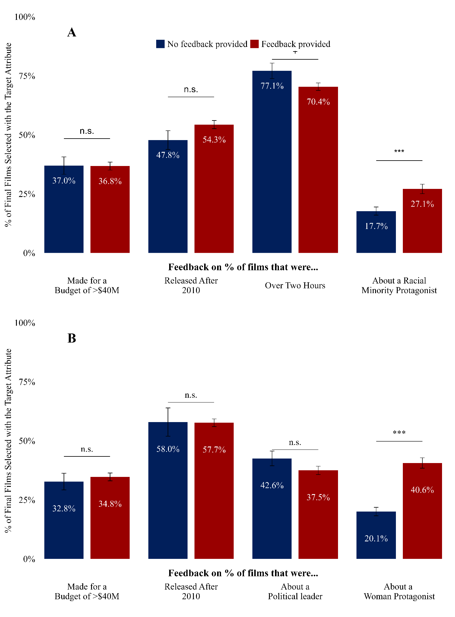

*Notes:* Figure S2 presents the percentage of participants by experimental condition who selected a final film with a given attribute. **(A)** presents results from Study 3A and **(B)** presents results from Study 3B. The x-axis labels indicate which film attribute was (randomly) targeted with feedback (e.g., % of selected films that were released after 2010). The y-axis presents the percentage of the selected final films that had a given target attribute (e.g., a racial minority protagonist) matching the feedback target listed on the corresponding portion of the x-axis. The blue bars summarize the percentage of final films selected with a given attribute (e.g., a racial minority protagonist) when feedback on that target attribute was not provided. The red bars summarize the percentage of final films selected with a given attribute (e.g., a racial minority protagonist) when feedback on that target attribute was provided. The error bars represent +/- 1 standard error. n.s.;*p*≥0.1;+*p*<0.1;\**p*<0.05;\*\**p*<0.01;\*\*\**p*<0.001.

## 

## Figure S3. Study 4. The Effect of Random Assignment to Receive Different Pieces of Descriptive Feedback about Prior Author Selections on Which Author is Subsequently Added to the Library Reading List in Study 4A (Panel A) and Study 4B (Panel B)

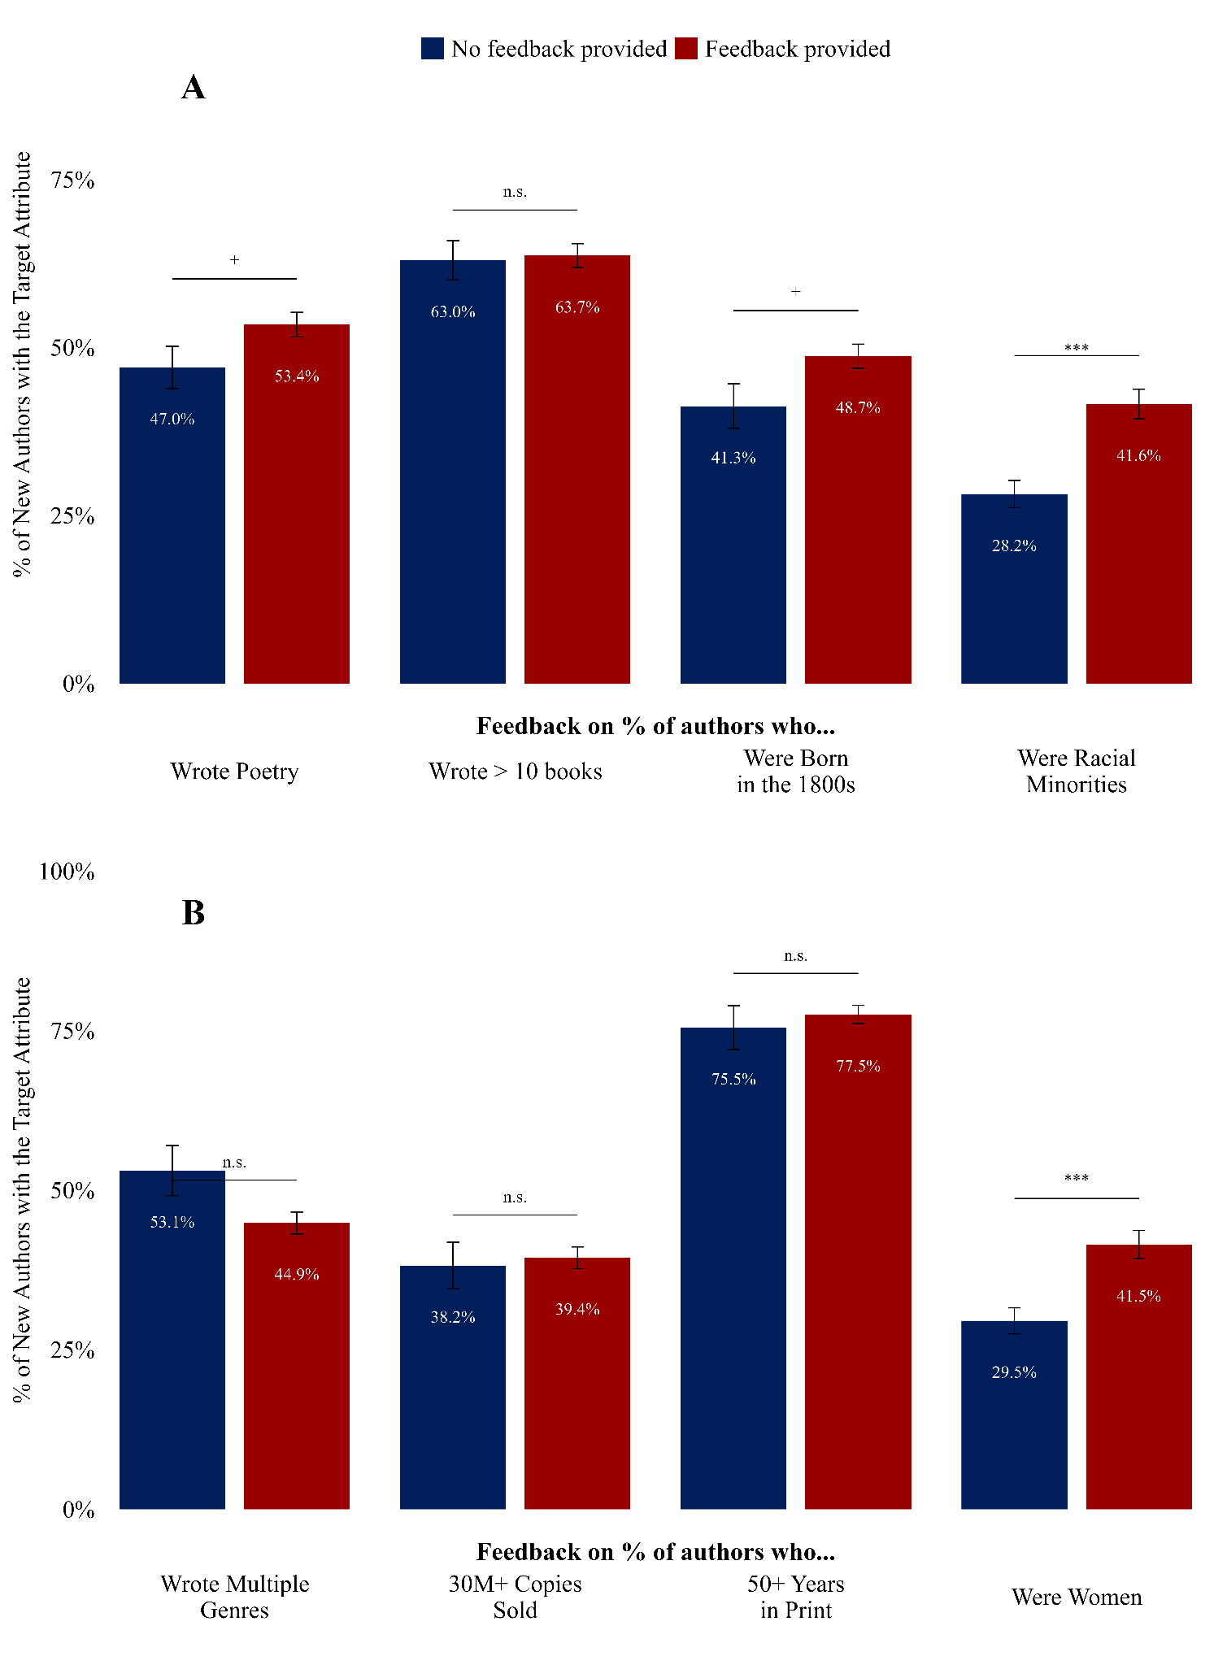

*Notes:* Figure S3 presents the percentage of participants by experimental condition who selected a final author with a given attribute. (**A**) presents results from Study 4A and (**B**) presents results from Study 4B. The x-axis labels indicate which author attribute was (randomly) targeted with feedback (e.g., % of authors who were racial minorities; % of authors who wrote works spanning multiple genres). The y-axis presents the percentage of the selected seventh and final authors that had a given target attribute (e.g., was a racial minority; was a woman) matching the feedback target listed on the corresponding portion of the x-axis. The blue bars summarize the percentage of final authors selected with a given attribute when feedback on that target attribute was not provided. The red bars summarize the percentage of final authors selected with a given attribute when feedback on that target attribute was provided. The error bars represent +/- 1 standard error. n*.*s*.* *p* ≥0.1; +*p*<0.1\**p*<0.05 \*\**p*<0.01 \*\*\**p*<0.001.

## Figure S4. Study S1. The Effect of Random Assignment to Receive Descriptive Feedback on Different Attributes of the Six People Initially Selected for a Panel on Who is Subsequently Chosen As the Final Panelist.

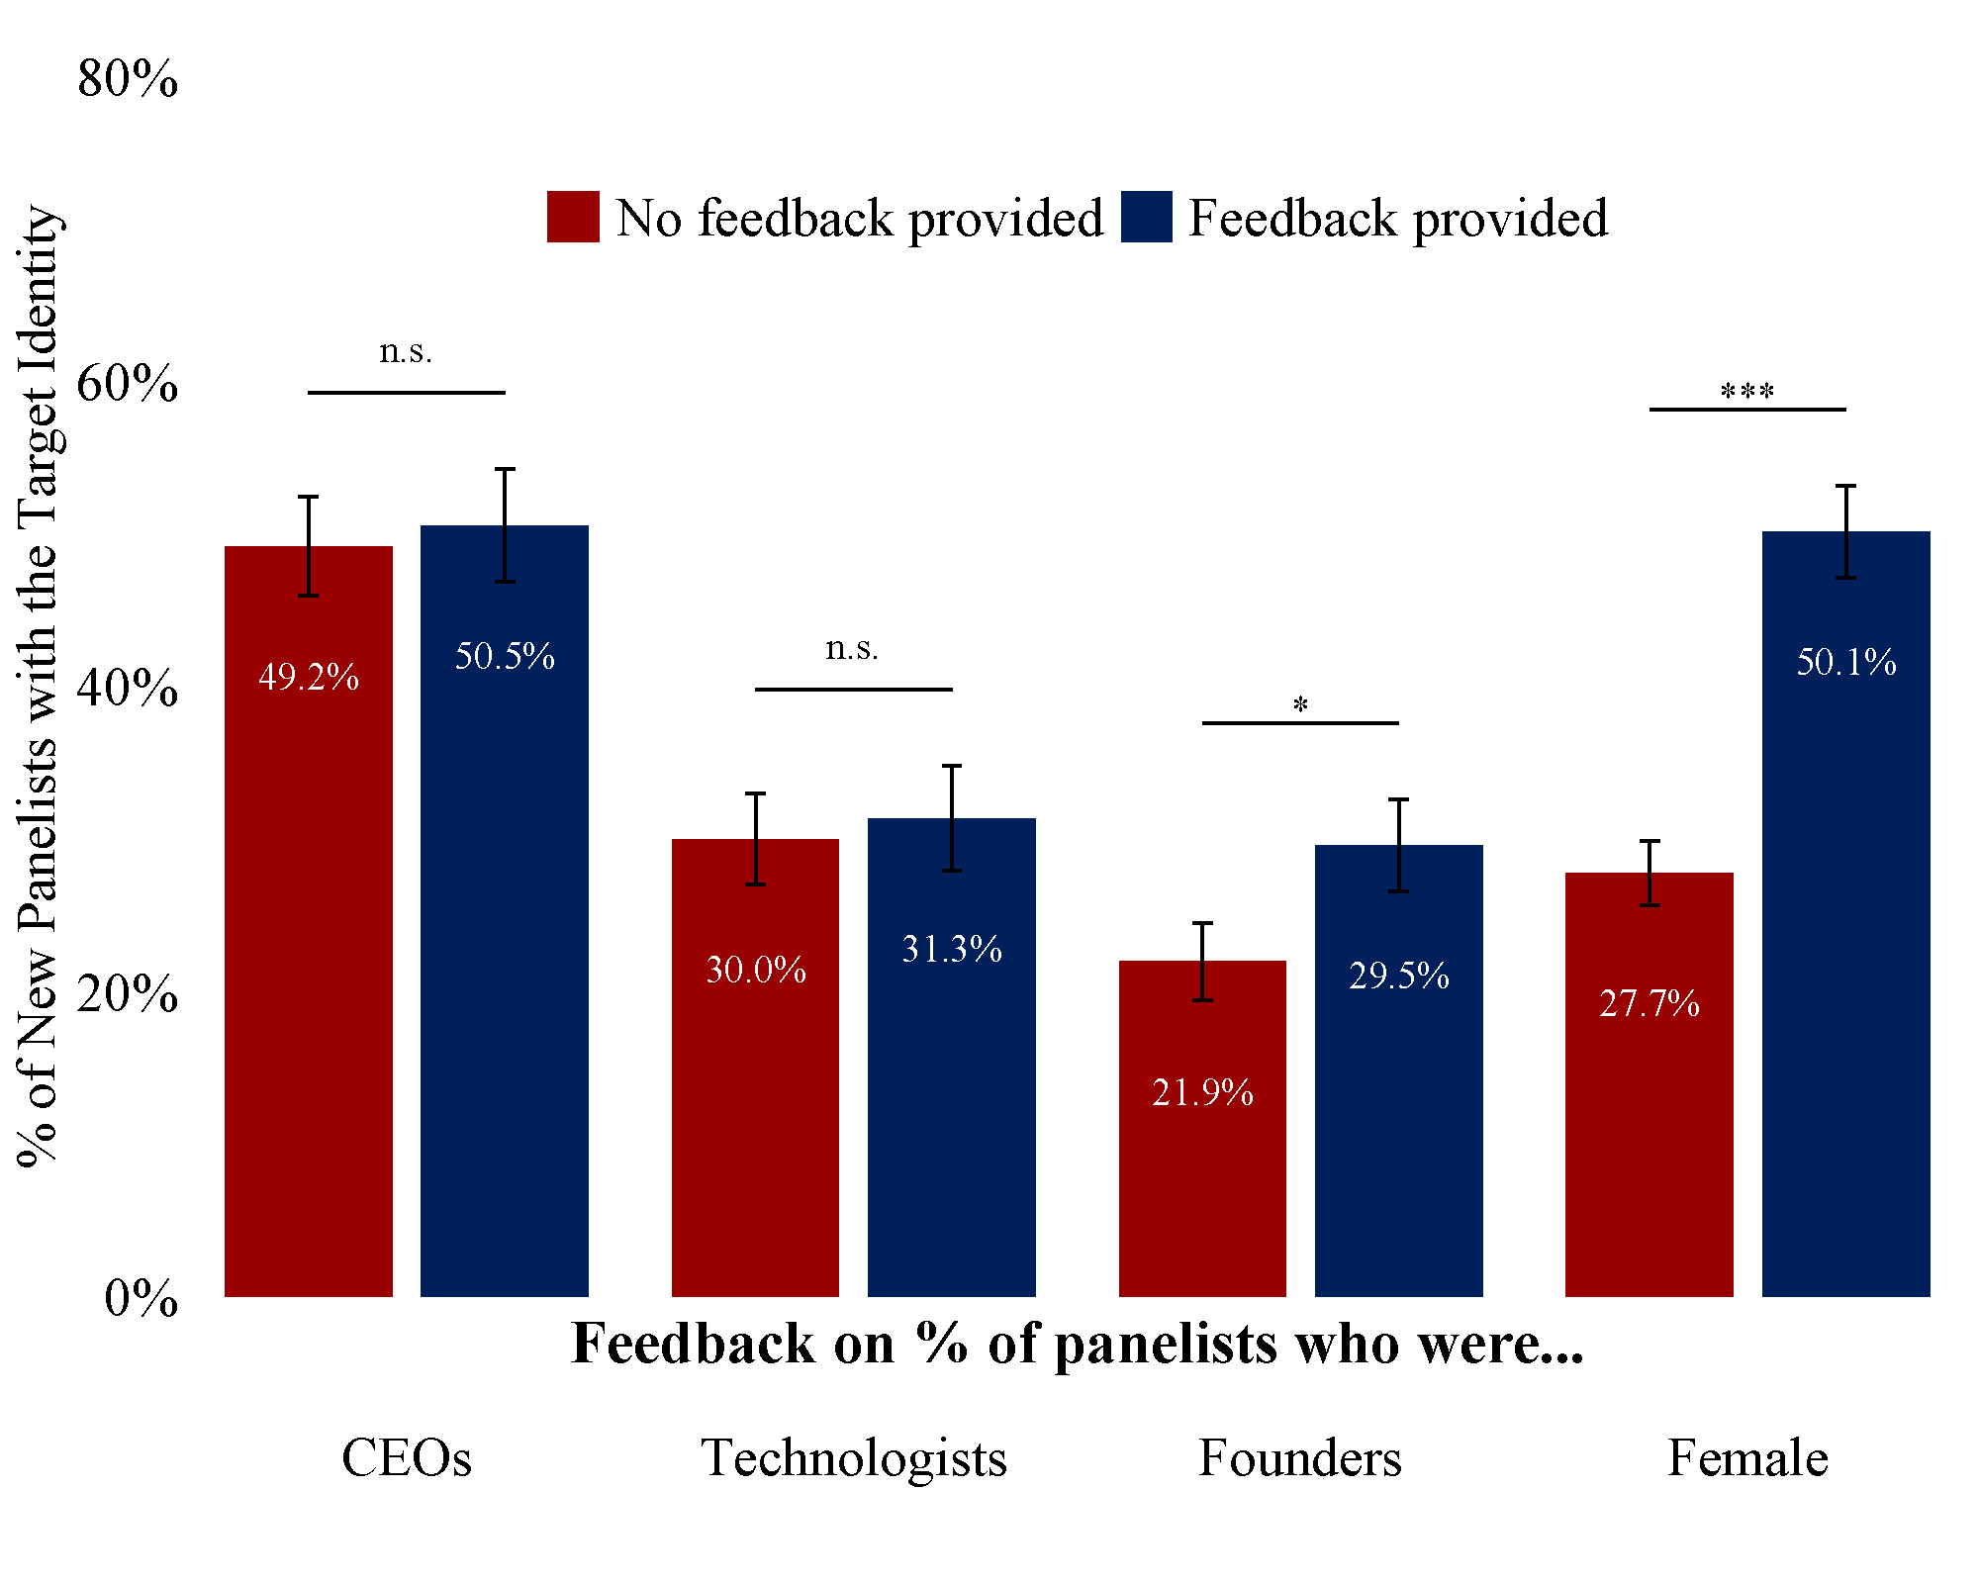

*Notes:* Figure S4 presents the percentage of participants who selected a seventh panelist with a given attribute by experimental condition. The x-axis labels indicate different attributes of the original set of panelists that were experimentally targeted with descriptive feedback (or a lack thereof) in this study (e.g., % of panelists who were women). The y-axis presents the percentage of those selected for the final panelist slot who had the target identity described on the corresponding portion of the x-axis. The gray bars summarize the percentage of the time the final panelist selected had the target attribute when feedback on that target attribute was not provided. The gold bars summarize the percentage of the time the final panelist selected had the target attribute when feedback on that target attribute was provided. The error bars represent +/- 1 standard error.

* *p*<0.05; ** *p*<0.01; *** *p*<0.001.

## Figure S5. Study S2A. The Effect of Random Assignment to Receive Descriptive Feedback on a Set of 6 Original Business Panel Selections on Which Business Panelist is Subsequently Chosen to be Featured as the 7th Panelist, among Participants both Encouraged to Focus on Diversity and Not Encouraged to Focus on Diversity.

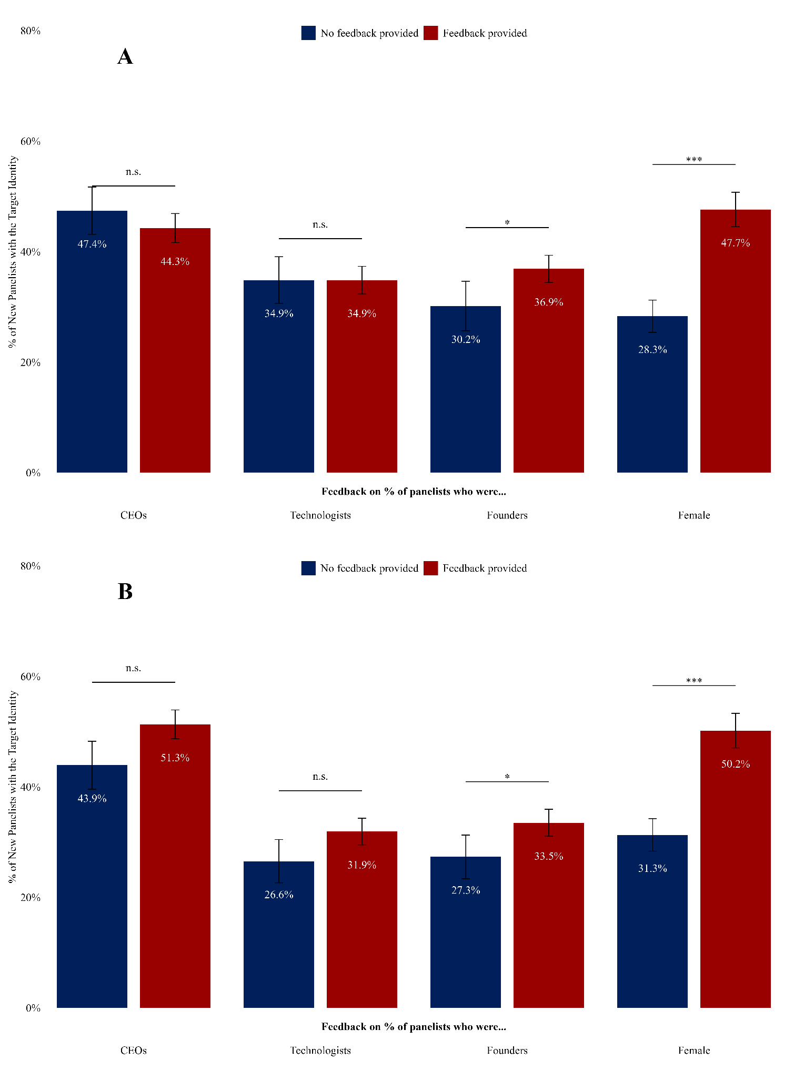

*Notes:* (**A)** presents the percentage of participants who selected a seventh panelist with a given attribute subset among the participants who were only in the *feedback* conditions (*N*=496). **(B)** presents the percentage of participants who selected a seventh panelist with a given attribute subset among the participants who were in the *encouragement* conditions (*N*=504). The x-axis labels indicate which identity attribute of the members of the original panel was targeted with feedback (e.g., % of panelists who were women). The y-axis presents the percentage of those selected for the final panelist slot who had the target identity described on the corresponding portion of the x-axis. The gray bars summarize the percentage of seventh and final panelists selected when the target feedback attribute was not provided. The brown bars summarize the percentage of seventh and final panelists selected when the target feedback attribute was provided. The error bars represent +/- 1 standard error. n.s. *p* ≥0.1; + *p*<0.1; * *p*<0.05; ** *p*<0.01; *** *p*<0.001.

## Figure S6. Study S2B. The Effect of Random Assignment to Receive Descriptive Feedback on a Set of 6 Original Podcast Selections on Which Podcast is Subsequently Chosen to be Featured as the 7th Podcast, among Participants Encouraged to Focus on Diversity and not Encouraged to Focus on Diversity

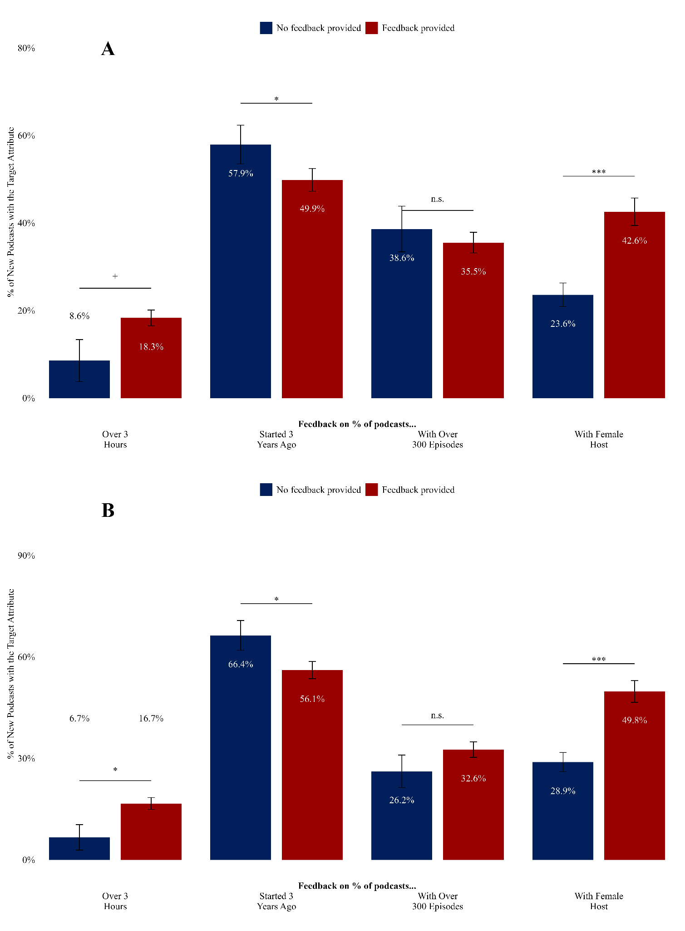

*Notes:* (A) presents the percentage of participants who selected a seventh podcast with a given attribute among the participants who were only in the feedback conditions. (B) presents the percentage of participants who selected a seventh podcast with a given attribute among the participants who were in the encouragement conditions. The x-axis labels indicate which feedback attribute of the original podcasts was targeted (e.g., % of podcasts that had a certain attribute). The y-axis presents the percentage of those selected for the final podcast who had the target attribute described on the corresponding portion of the x-axis. The gray bars summarize the percentage of seventh podcasts selected when the target feedback attribute was not provided. The gold bars summarize the percentage of seventh podcasts selected when the target feedback attribute was provided. The error bars represent +/- 1 standard error. n.s. *p* ≥0.1; + *p*<0.1; * *p*<0.05; ** *p*<0.01; *** *p*<0.001

# Materials

## Study 1

[Instructions]

## 

[Non-gender feedback]

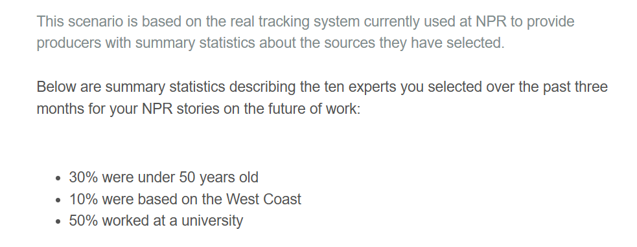

[Gender feedback]

## 

## 

[Stimuli selection instructions[1]]

## 

## 

[Stimuli]

## 

## Study 2

Study 4 was a much shorter study since it was done in the field, therefore we had a script for research assistants to use for providing instructions and the first page of the survey was the stimuli below.

Field Experiment Script:

**Hook**:

* Hi! We’re part of a campus group holding a vote on which biographies of important people should be put up on display at Wharton. Do you have two minutes to vote? Everyone who votes gets a candy bar!

**Follow-up:**

* The vote is on which biographies we should display in Huntsman Hall. As you can see here [show laminated photo of display case], the winning selections will be recommended and set out on display.
* The goal is to encourage more non-fiction reading by Penn community members. We’d really appreciate your vote on which books to recommend. We have a set of candidates but need to winnow them down. It will take 2 minutes and just involves a few clicks on this iPad [hold out iPad] to vote anonymously.
* And of course, you can pick which candy you’d like as a thank you for your time.

**Question bank:**

1. Is this an experiment?
   1. This is part of an effort to promote more reading on campus.
   2. (Continue to promote that the purpose of the project is to promote reading.)
2. Who is organizing this?
   1. A group of faculty and students at Wharton
3. Why are you doing this?
   1. To promote more reading no campus and engagement with non-fiction books about inspiring people.
4. Where will the results be posted?
   1. The books will be on display on the 5th floor of JMHH. Please stop by anytime in late April to check them out!
5. Are my votes anonymous?
   1. Yes
6. Is there any incentive for doing this?
   1. Absolutely. We’ll give you a candy bar, and we’ll be grateful for your help.

[Stimuli of Biographies]

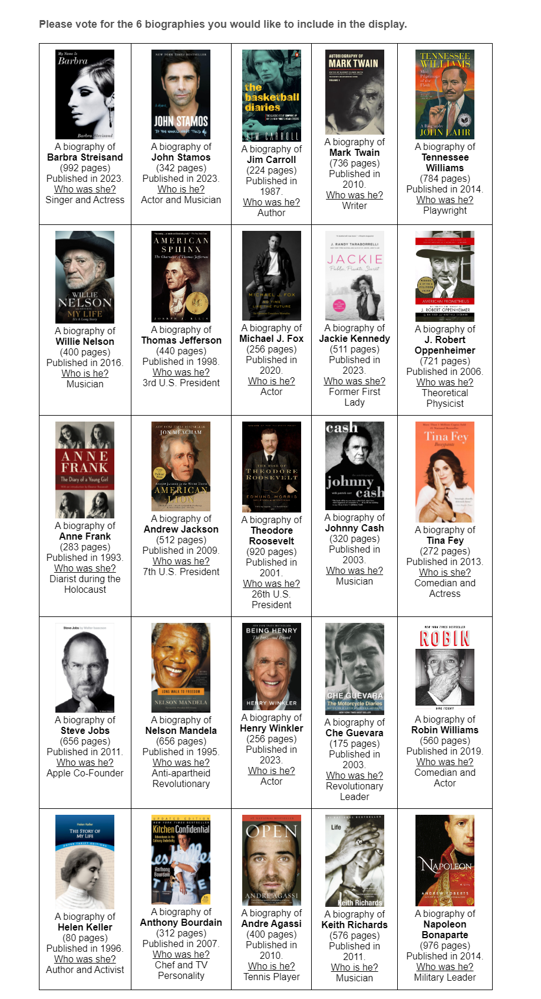[Non-Gender Feedback]

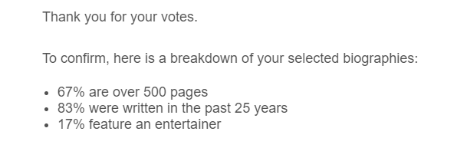

[Gender Feedback]

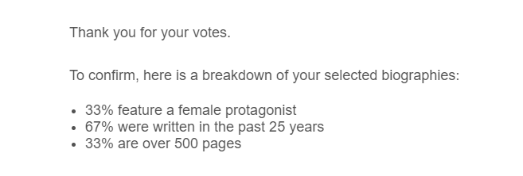

[DV Selection Page[2]]  
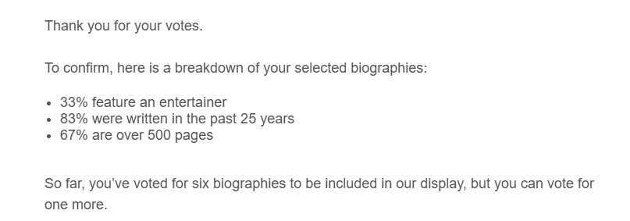

[Stimuli]

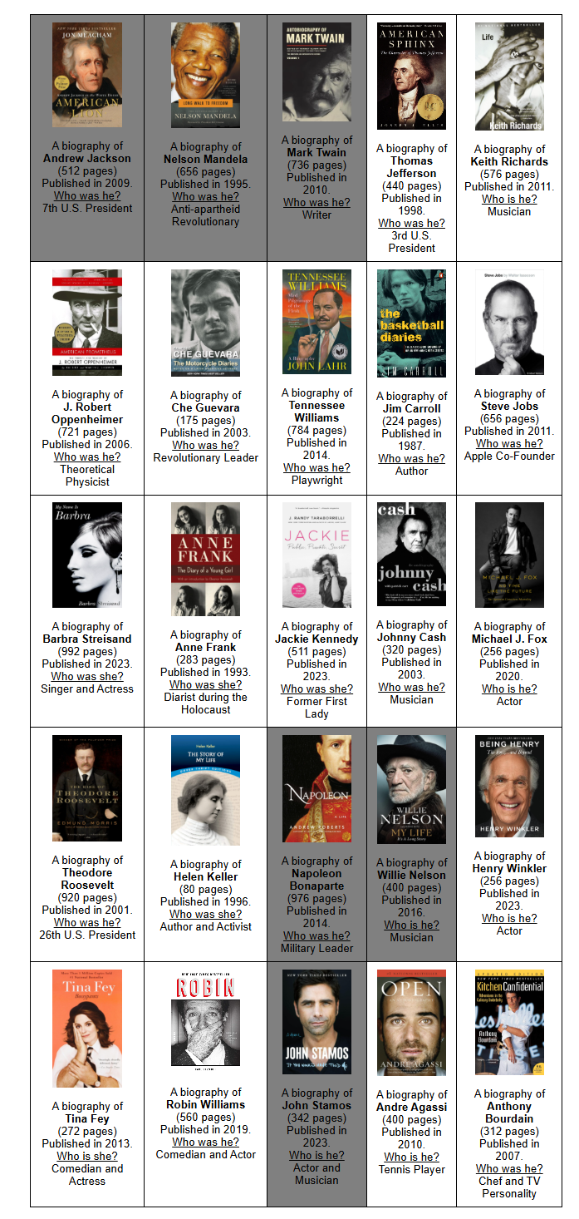

## Study 3A

[Instructions]

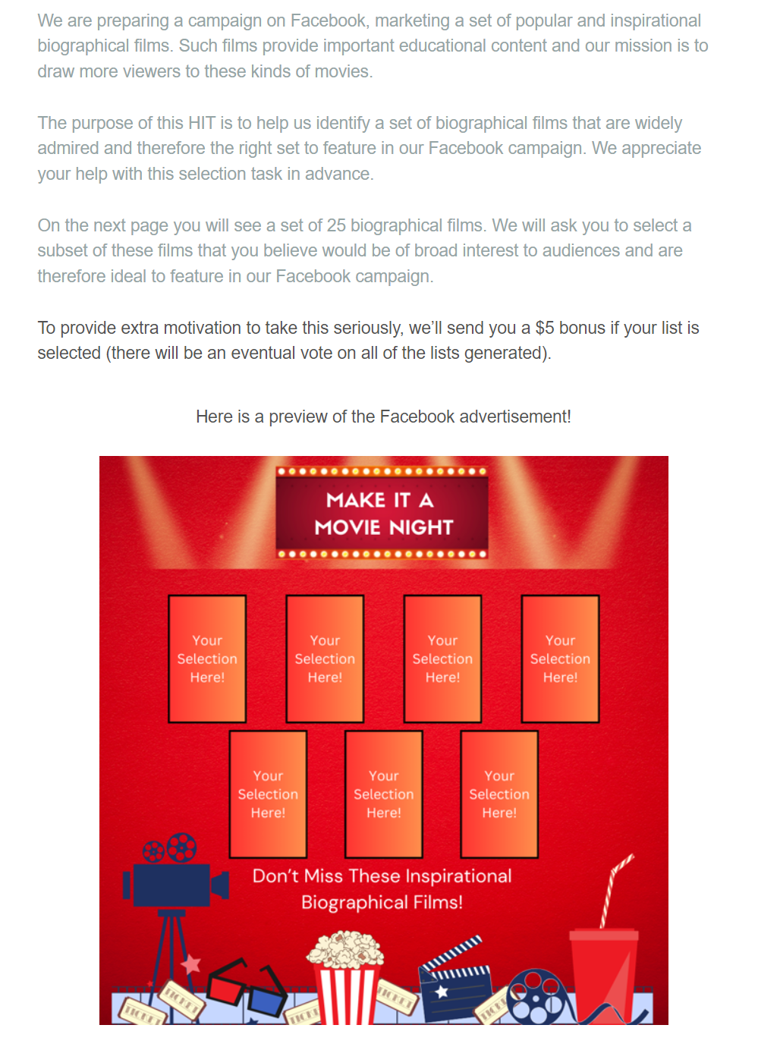

## 

## 

[Stimuli of Biographical Films]

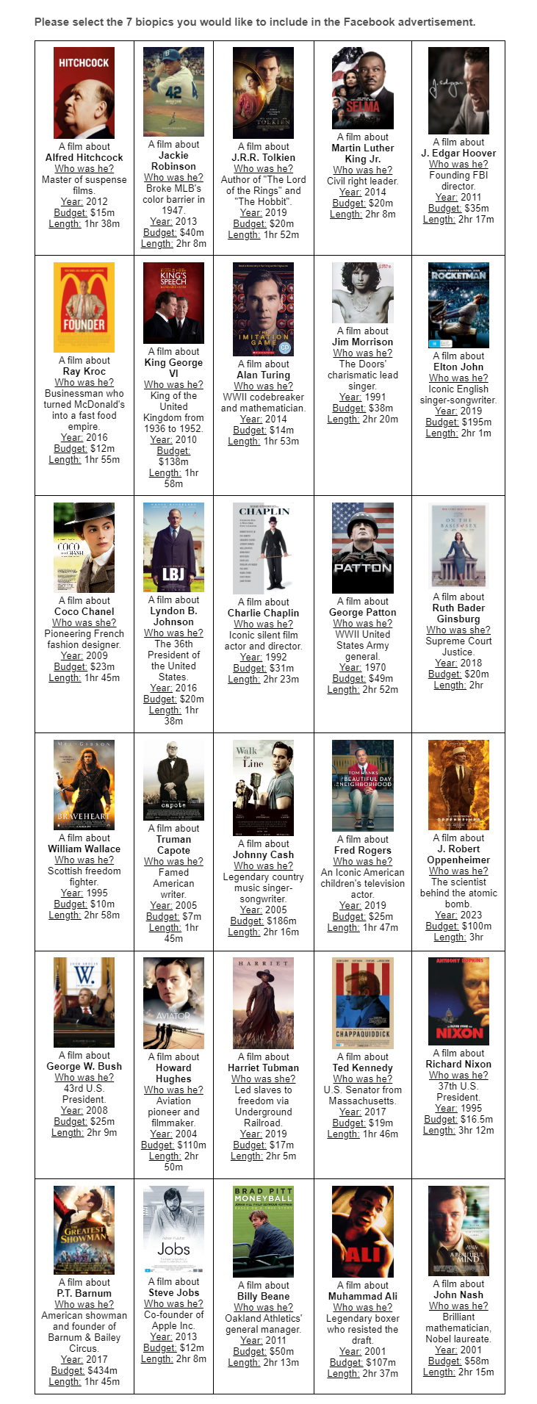

[Non-Race Feedback]

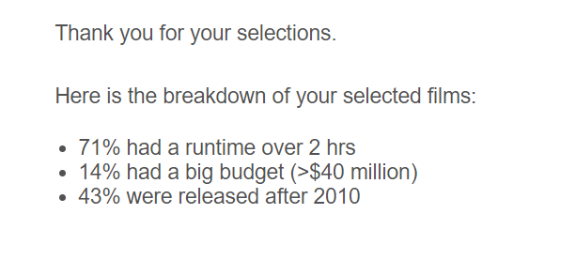

[Race Feedback]

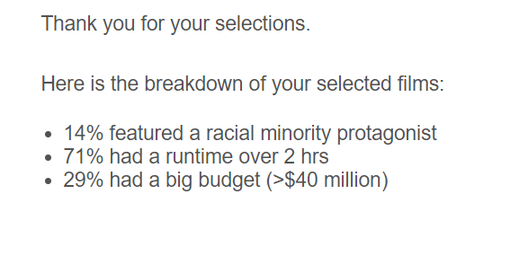

## 

[DV Selection]

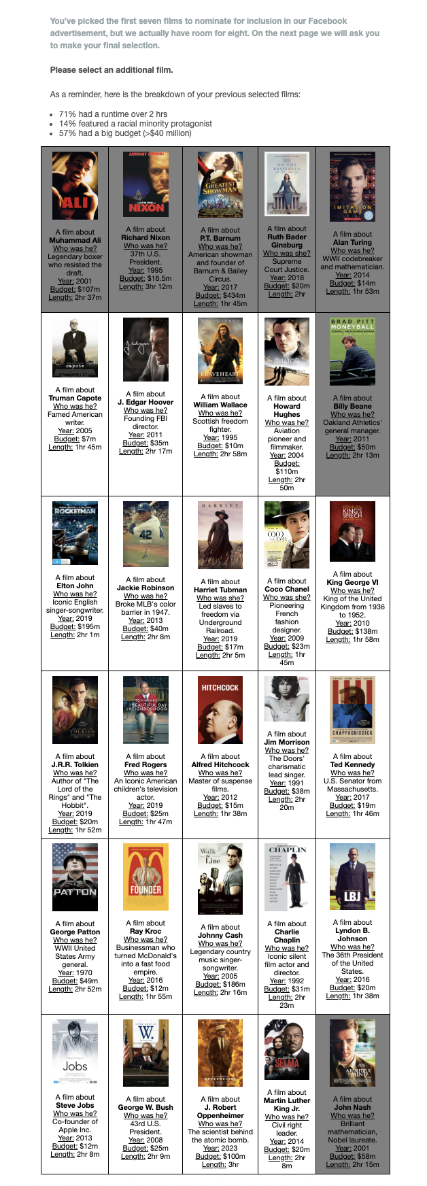

## Study 3B

[Instructions]



[Stimuli of Biographical Films]

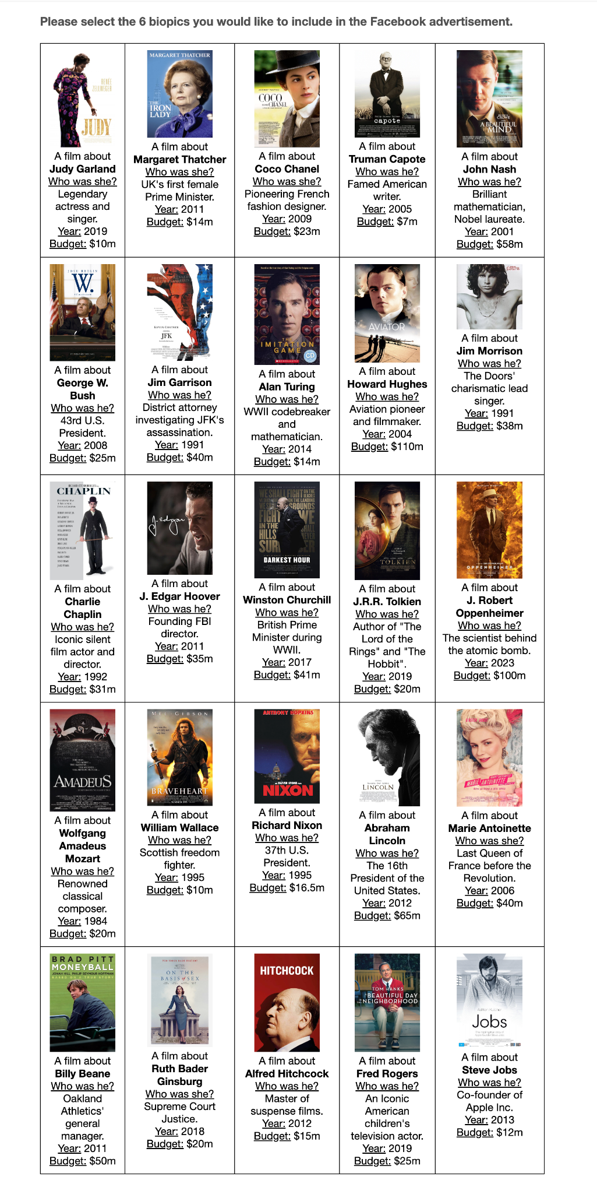

[Non-Gender Feedback]

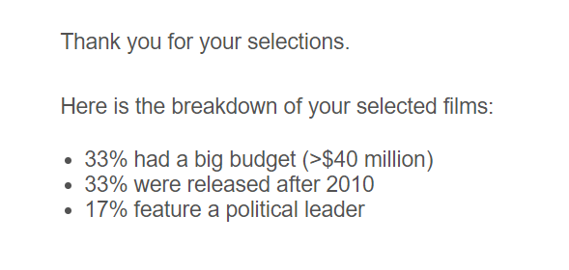

[Gender Feedback]

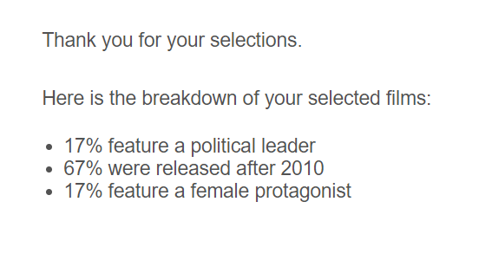

[DV Selection]

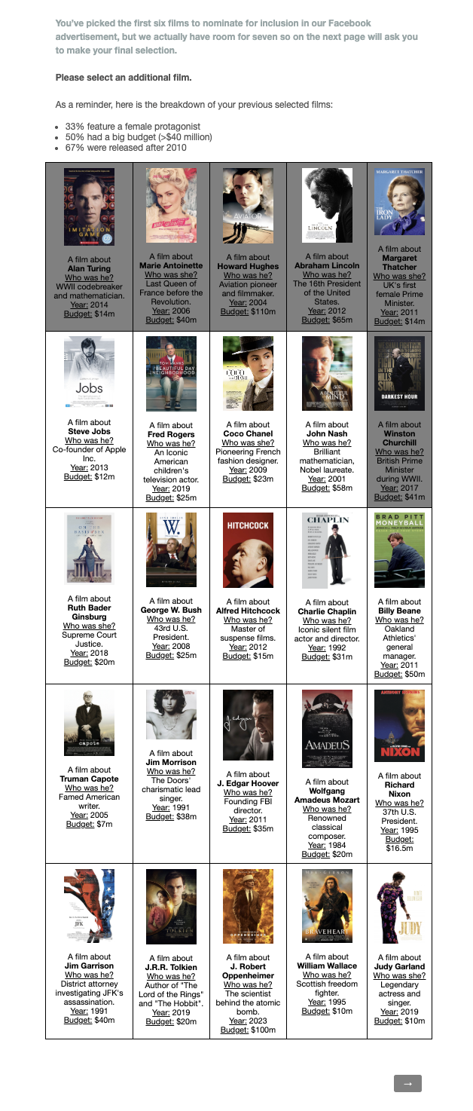

## Study 4A

[Instructions]

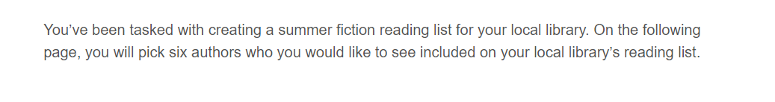

[Stimuli of Authors]

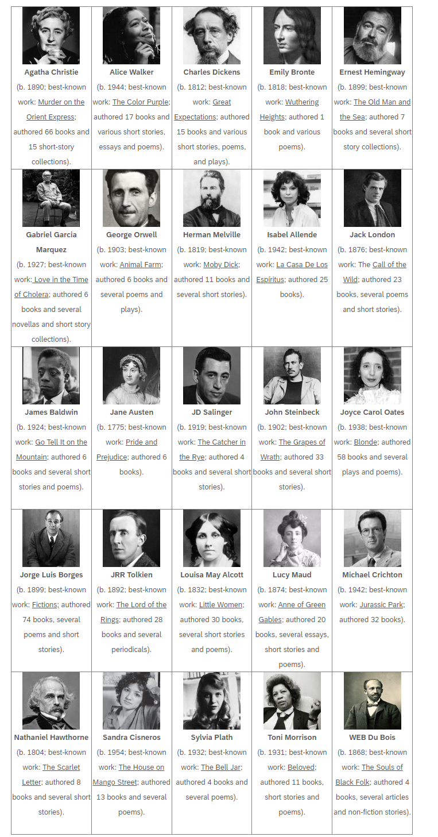[Non-Race Feedback]

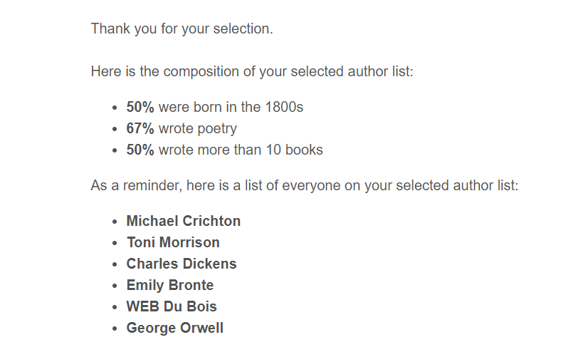

[Race Feedback]

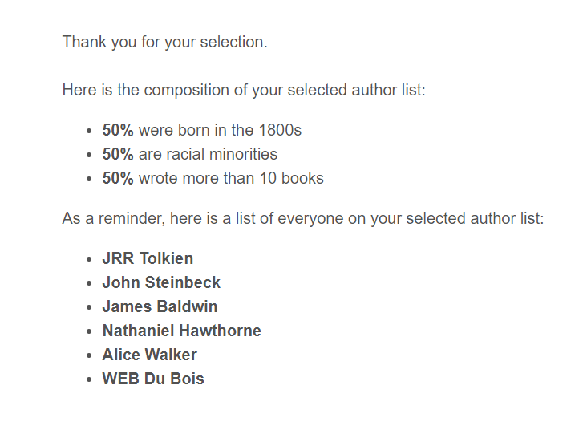

[DV Selection]

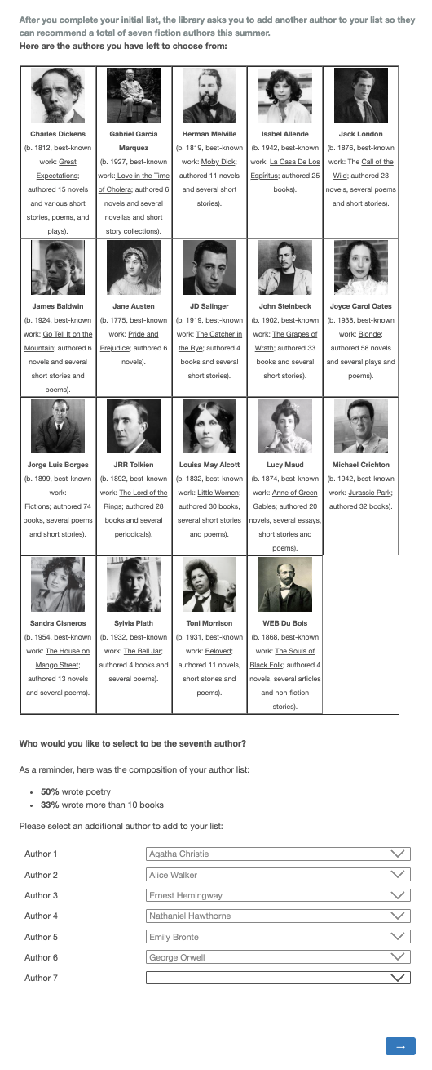

Motivation to respond without prejudice scale

The scale was measured on a 7-point Likert Scale from Strongly Disagree to Strongly Agree.

**Internal Motivation Items:**

1. When making my decision about who to select as my seventh author, I considered my personal commitment to not be racist.
2. Given my personal values and beliefs, an important factor in my selection of the seventh author to add to my list was my desire to promote the success of racial minorities.
3. When deciding about who to select as my seventh author, I considered how personally important it is to me to support racial minorities.
4. In making my decision about who to select as my seventh author, I prioritized my personal motivation to ensure that racial minorities have the same visibility as others.

**External Motivation Items:**

1. Given today's political correctness standards, a factor in my decision about who to select as my seventh author was that I should do my best not to act sexist.
2. When making my decision about who to select as my seventh author, I considered the social pressures I face to appear to promote racial minorities where they are typically underrepresented.
3. In making my decision about who to select as my seventh author, I considered my desire to not appear racist in order to avoid negative reactions from others.

The items were adapted from Plant & Devine (1998)

## Study 4B

[Instructions]



[Stimuli of Authors]

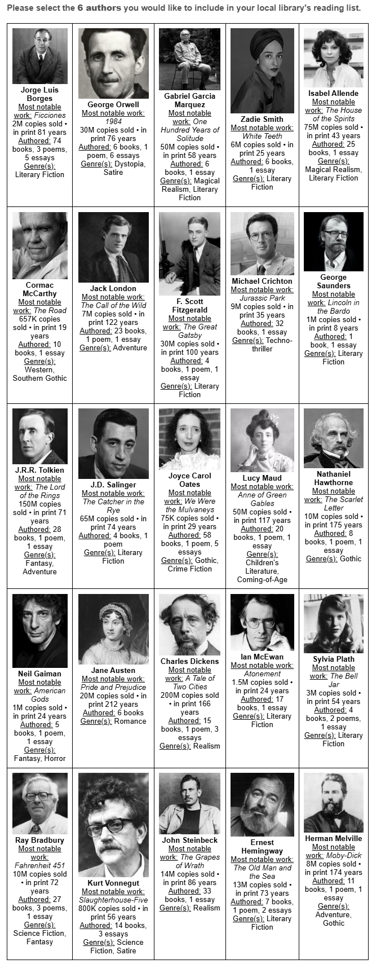

[DV Selection]

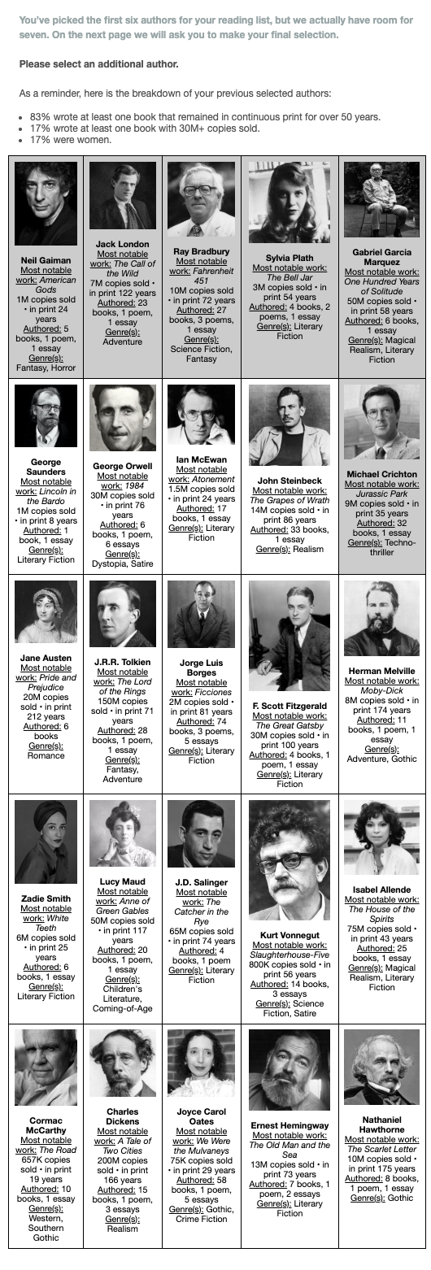

[Non-Gender Feedback]

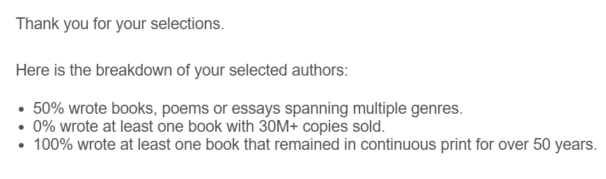

[Gender Feedback]

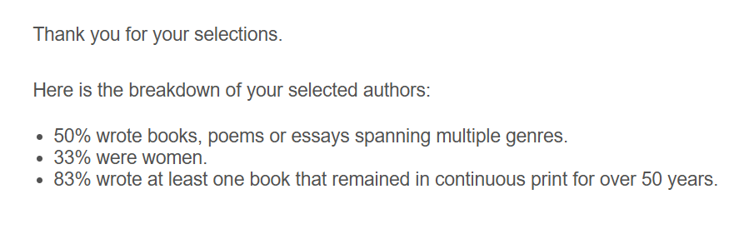

Motivation to respond without prejudice scale (adapted for gender)

The scale was measured on a 7-point Likert Scale from Strongly Disagree to Strongly Agree.

**Internal Motivation Items:**

1. When making my decision about who to select as my seventh author, I considered my personal commitment to not be sexist.
2. Given my personal values and beliefs, an important factor in my selection of the seventh author to add to my list was my desire to promote the success of women.
3. When deciding about who to select as my seventh author, I considered how personally important it is to me to support women.
4. In making my decision about who to select as my seventh author, I prioritized my personal motivation to ensure that women have the same visibility as others.

**External Motivation Items:**

1. Given today's political correctness standards, a factor in my decision about who to select as my seventh author was that I should do my best not to act sexist.
2. When making my decision about who to select as my seventh author, I considered the social pressures I face to appear to promote women where they are typically underrepresented.
3. In making my decision about who to select as my seventh author, I considered my desire to not appear sexist in order to avoid negative reactions from others.

The items were adapted from Plant & Devine (1998) and were modified to measure women's prejudice.

## Study 5

[Instructions]

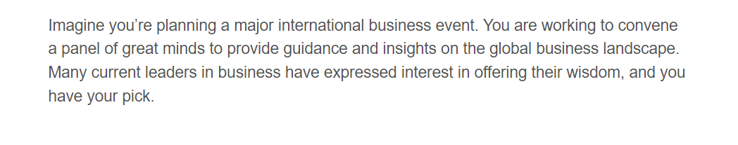

[Stimuli – Women Overrepresented Set]

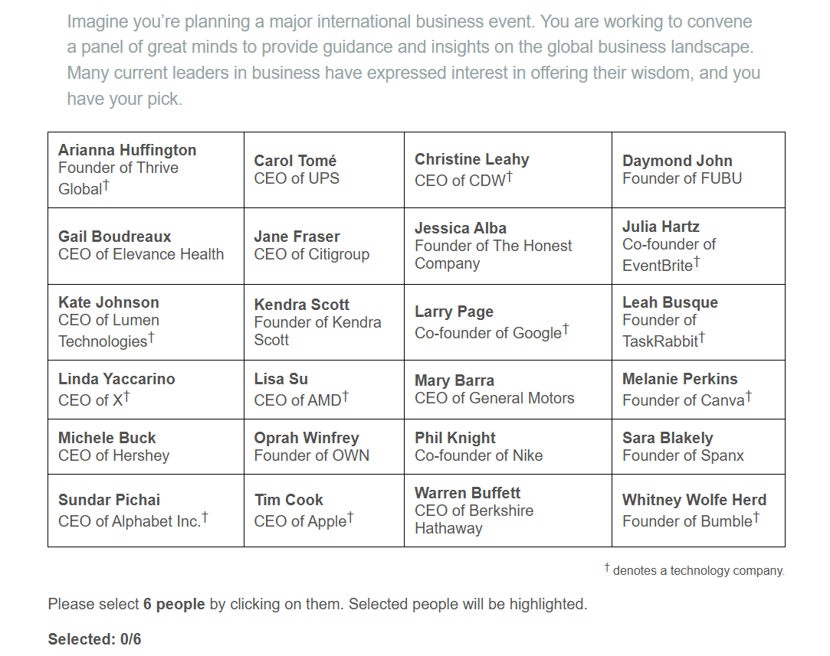

[Stimuli – Women Underrepresented Set]

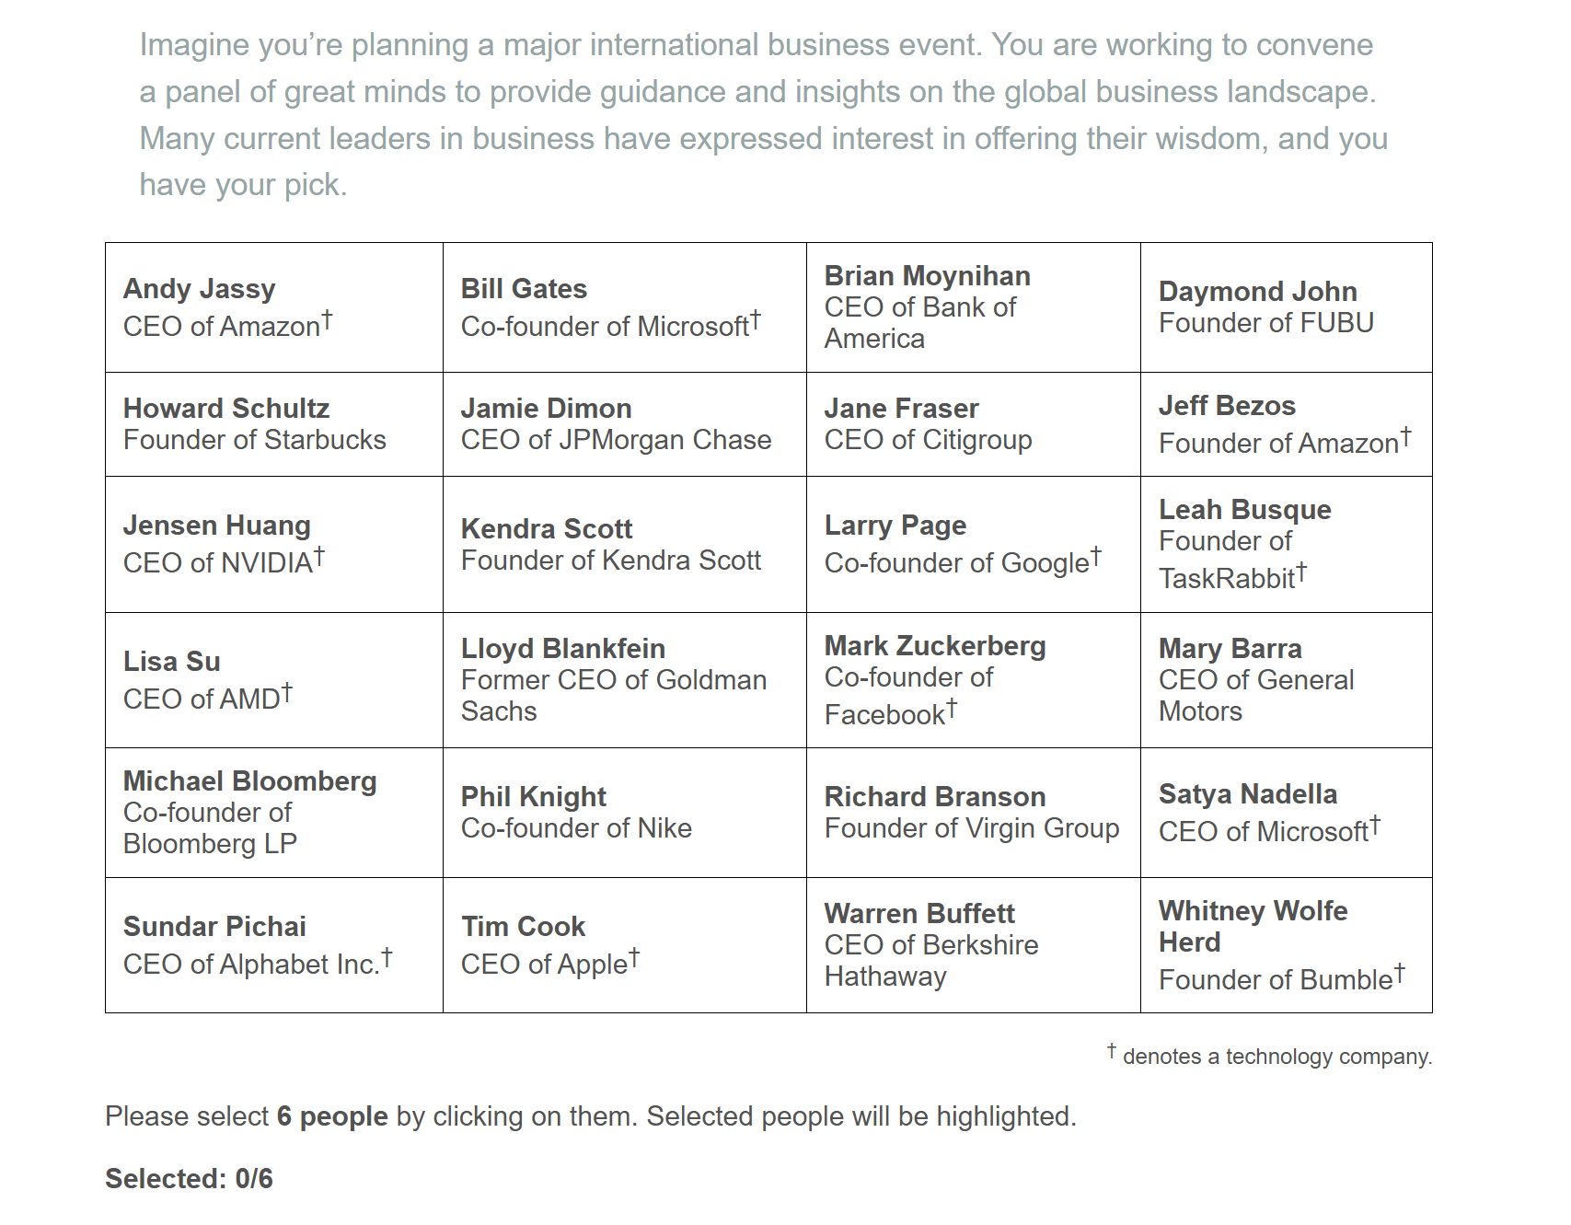

[Non-Gender Feedback]

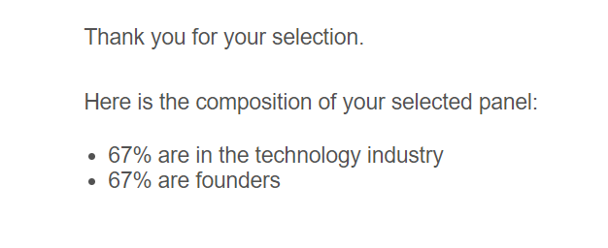

[Gender Feedback]

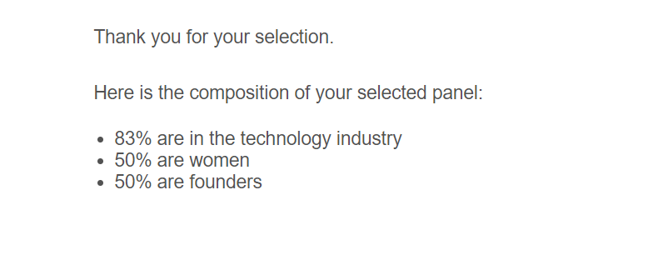

[DV Selection]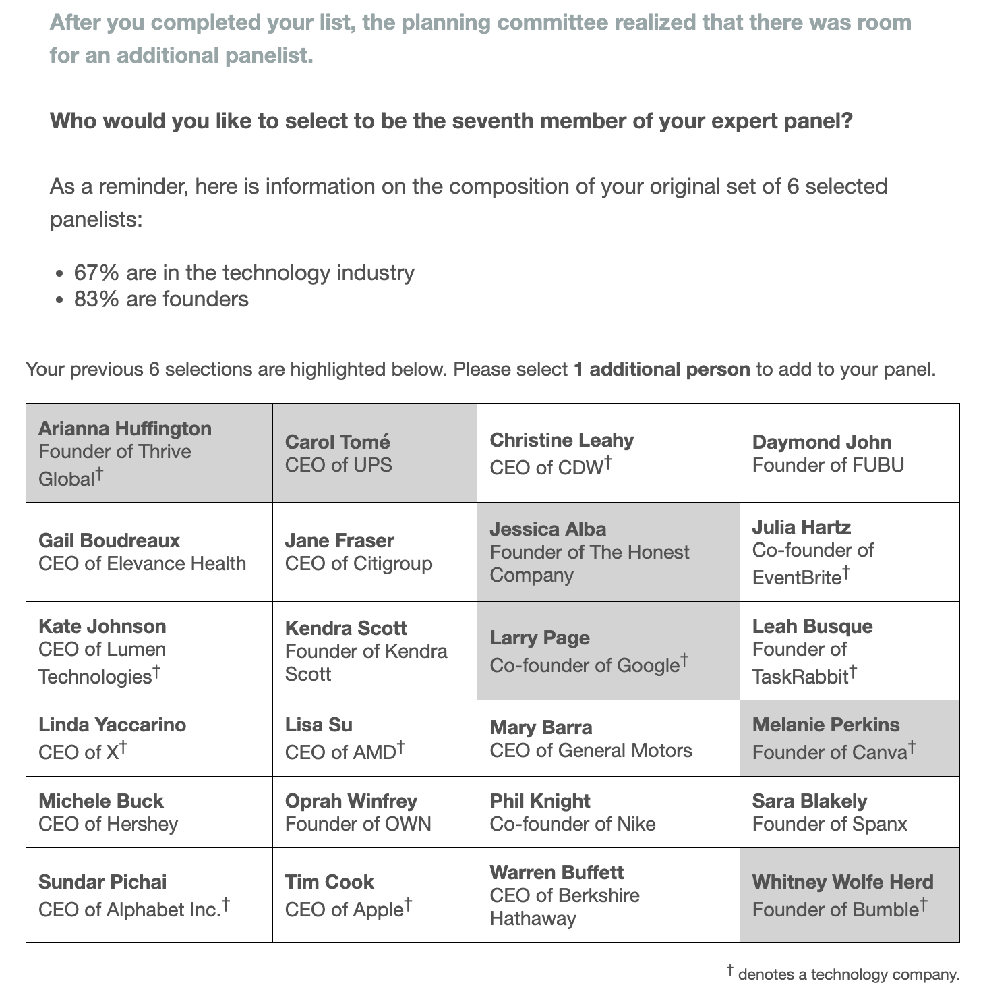

**Fairness concerns items**  
  
The scale was measured on a 7-point Likert Scale from Strongly Disagree to Strongly Agree.   
  
Please rate the extent to which you agree with each of the following statements:

1. When deciding who to add as my seventh panelist, I prioritized achieving a degree of balance in the representation of men and women.
2. An important factor when deciding who to add as my seventh panelist was avoiding extreme over- or under-representation of men or women.
3. I aimed to ensure that neither men nor women were left out when making my final decision.

## 

Motivation to respond without prejudice scale

The scale was measured on a 7-point Likert Scale from Strongly Disagree to Strongly Agree.

**Internal Motivation Items:**

1. When making my decision about which seventh panelist to select, I considered my personal commitment to not be sexist.
2. Given my personal values and beliefs, an important factor in my selection of my seventh panelist was my desire to promote the success of people of both genders.
3. When deciding which seventh panelist to select, I considered how personally important it is to me to support people of both genders.
4. In making my decision about which seventh panelist to select, I prioritized my personal motivation to ensure that people of both genders have the same visibility.

**External Motivation Items:**

1. Given today's political correctness standards, a factor in my decision about which seventh panelist to select was that I should do my best not to act sexist.
2. When making my decision about which seventh panelist to select, I considered the social pressures I face to appear to promote both men and women in any setting where one group is typically underrepresented.
3. In making my decision about which seventh panelist to select, I considered my desire to not appear sexist in order to avoid negative reactions from others.

The items were adapted from Plant & Devine (1998)

## Study S1

[Instructions]

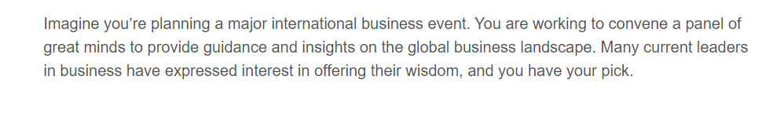

## 

[Stimuli of Business Leaders]

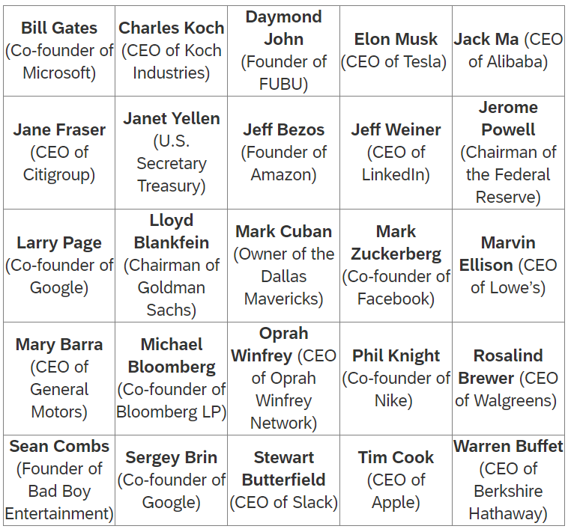

## 

[Non-Gender Feedback]

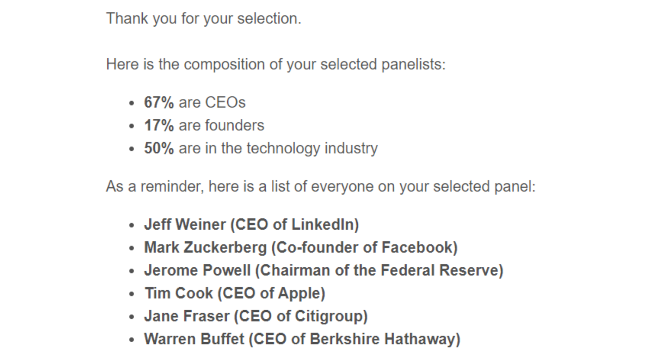

[Gender Feedback]

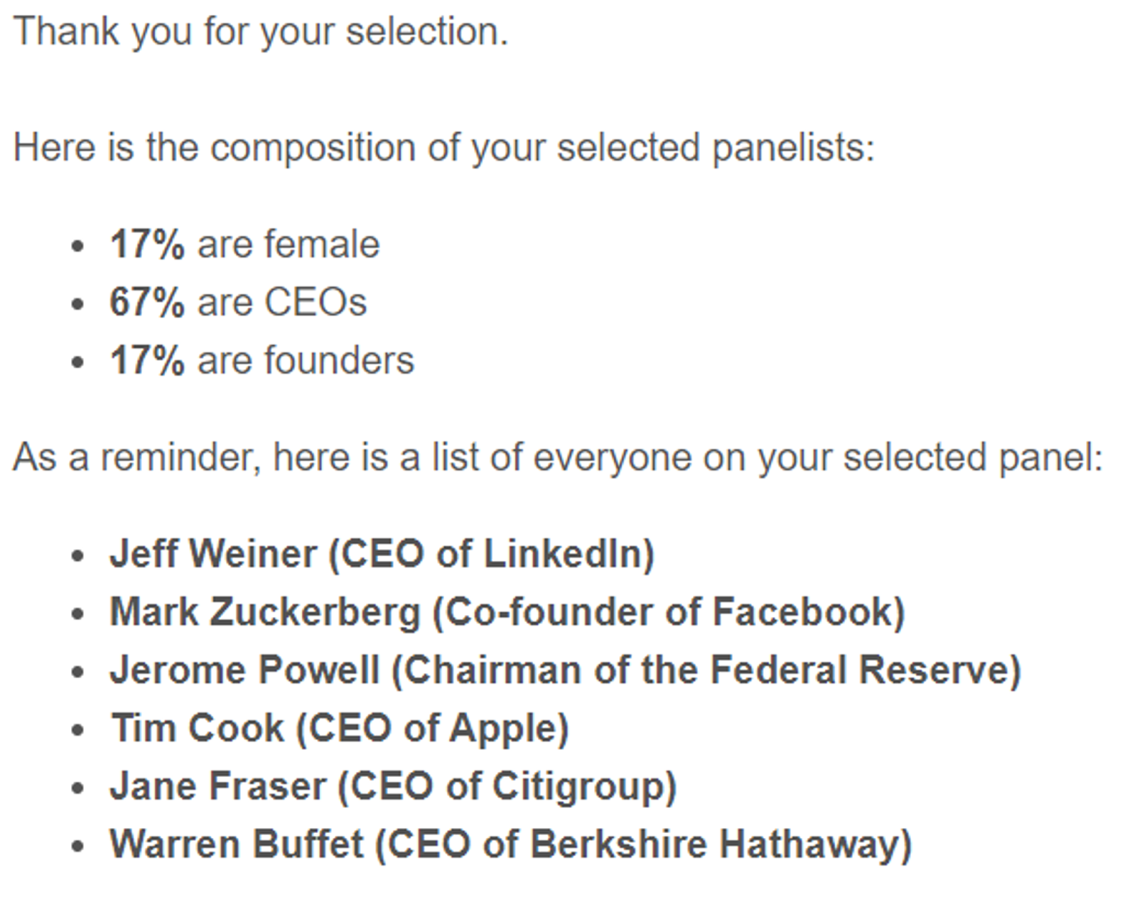

## Study S2A

[Instructions]



## 

[Stimuli of Business Leaders]



[Non-Gender Feedback]



[Gender Feedback]



[Non-Gender Feedback with Encouragement Message]



[Gender Feedback with Encouragement Message]



## Study S2B

[Instructions]



## 

[Stimuli of Podcasts]

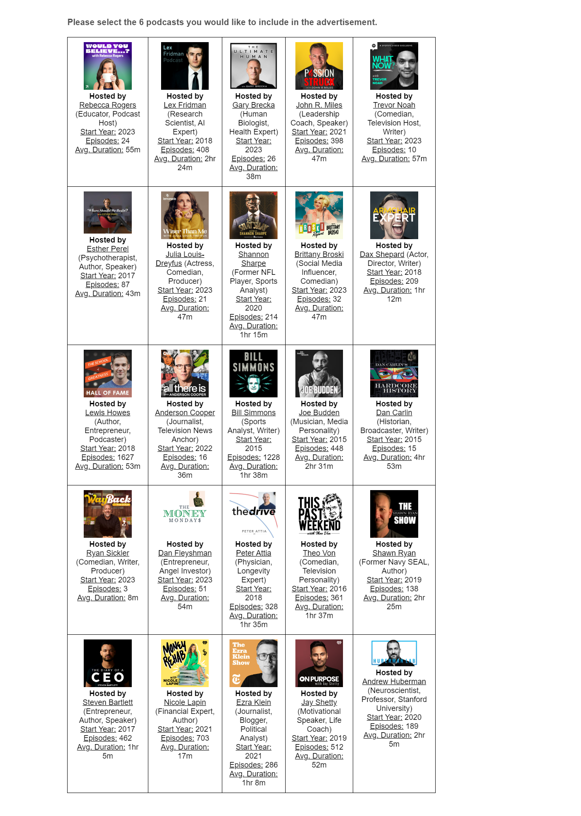

[Non-Gender Feedback]

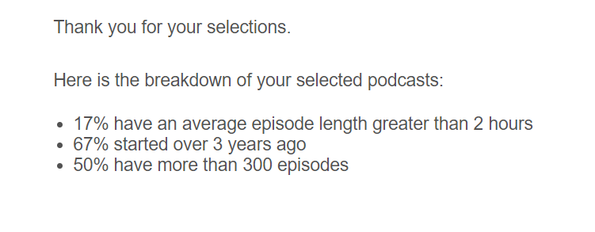

[Gender Feedback]

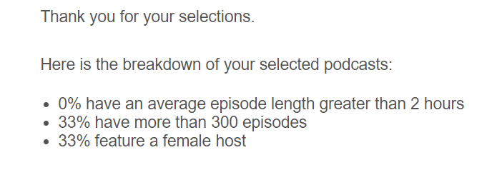

[Non-Gender Feedback with Encouragement Message]

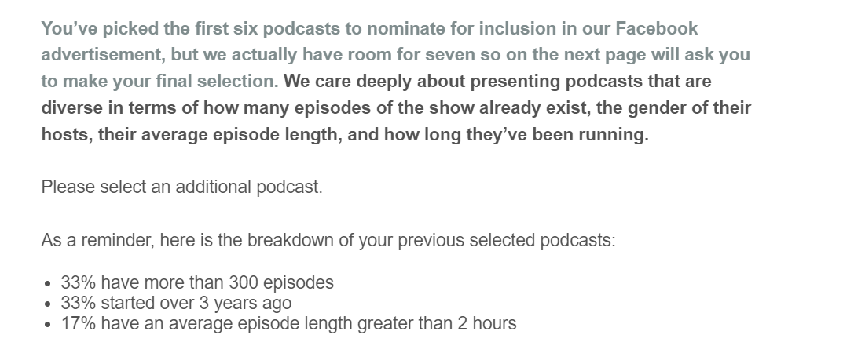

[Gender Feedback with Encouragement Message]

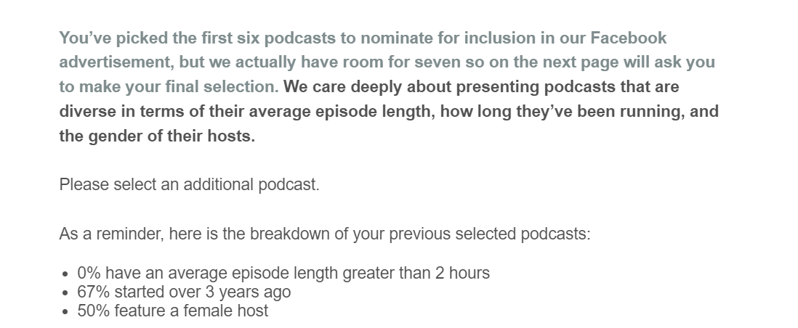

1. These instructions and the stimuli were displayed on the same page, but split out here due to space constraints.
2. These instructions and the stimuli were displayed on the same page, but split out here due to space constraints.